BRIAN HISTORY
BY
REV. WILLIAM PRESTON (TED) BRIAN
2724 East 10 Street
Odessa, Texas 79760
Price $8.00

DEDICATION

This book is lovingly dedicated to my wife Inez Cherry Brian, who has faithfully stood by in my ministry for thirty seven years and our four wonderful children, William Preston Jr., Annie Beth Brian Roby, Thomas Jefferson and Cherrydel.

By
Rev. W. P. Brian
This the 4th day of June
1971

LEGEND

- If you read and reread this book you will discover that our Brian ancestry has a glorious history.
- Our people were independent, determined, aggressive, humble, very devout and yet militant. As our Aunt Minnie Brian used to say, "Ted, you are like all the other Brians, hard headed."
- Our people were preachers, singers, chaplains, schoolteachers, missionaries, soldiers, farmers, doctors, ranchers and successful businessmen in all walks of life.
- Lastly, most of all our Brian relatives are Baptists, and have been through the ages. Very few have ever united or belonged to any other denomination or religion than that of the Baptist faith.

PREFACE

The purpose of the author is to call attention to the readers of the Present history of the descendants of these noble ancestors of the Brian generations, which should be indelibly fixed in the mind of every relative. It is a history that should have been written several years ago.

The author desired that some interested relative would search the various avenues of the Brian genealogy, and to outline and complete it in book form. He considered himself too incompetent for the important task. After having served for over twenty years in full time pastorates and then some ten years in mission work, he felt he did not have the time for such a gigantic task. But on November 7, 1956, 1 received a letter from Mrs. Blanche Brian Brown, Route 2, Inman, South Carolina. She had seen my name listed in the Home Mission Magazine of Southern Baptists as one of our missionaries. She asked me if I was related to Alfred Aaron Brian, who left Spartanburg, South Carolina, in 1880, and never wrote a letter home. I began to correspond with her and other kinsmen in South Carolina and received some very valuable information. Also some very informative history written by Mattie Liles Carpenter, a granddaughter of Thomas and Narcissus Camp Brian. This was enough to plant the seed for this book.

CONTENTS

1. KING BRIAN "BORU", 10
2. BRIAN "COAT OF ARMS, 12
3. HENRY II, 14
4. QUEEN MARY, 15
5. MARTYRS, 16
6. WILLIAM, CHARLES, AND JAMES BRIAN COME TO AMERICA, 17
7. THOMAS AND NARCISSUS CAMP BRIAN, 18
8. KINSMEN WHO LIVE IN SOUTH CAROLINA AND ELSEWHERE, 21
9. ALFRED AARON AND MATTIE McDOWELL BRIAN, 27
10. MOLLIE BRIAN McGUIRE, 32
11. PHILA BRIAN DUKE HENDRICKS, 33
12. FANNIE BRIAN TARRY, 34
13. JENNIE BRIAN WALSER, 37
14. JOE THOMAS BRIAN, 39
15. CUSTER BRIAN, 40
16. CALVIN McDOWELL AND IRENE BLUNT BRIAN, 41
17. MOSES B. AND MINNIE SPIZER BRIAN, 43
18. KLEBER DESSEX AND ELIZABETH MELTON BRIAN, 44
19. CORA BELL BRIAN GREENHAW, 54
20. NORMA JEFF BRIAN BRISCO, 57
21. LOUCILLE BRIAN EVITT, 60
22. ALFRED AARON II AND ORA DOPSON BRIAN, 64
23. MELTON DESSEX AND MAMMIE CRAIG BRIAN, 69
24. ROSA VICTORIA BRIAN HOWARD, 72
25. WALTER LEE AND EUPHIA SMITH BRIAN, 74
26. WILLIAM PRESTON (TED) AND INEZ CHERRY BRIAN, 76
27. DALTON DELMONT AND JOY SMITH BRIAN, 79
28. SAMUEL ELLIS AND BILLIE SWAIN BRIAN, 81
29. CAVORTING, 84
30. ANDREW EVANGELISM, 86
31. YAP, 89
32. WOW, 91
34. MEN OF VALOR, 96
35. XENIA, 102
ACCOMPLISHMENTS, 94
BIBLIOGRAPHY, 8
DEDICATION, 2
EXPLANATION, 7
FOREWORD, 6
INTRODUCTION, 9
LEGEND, 3
PREFACE, 4
RUFUS BRIAN FAMILY, 71

FOREWORD

It is the sincere desire of the author that this family record may be found of value to subsequent family historians who may be able to write a more decisive history than this one. These pages are not flawless and some of the facts and dates may not be exactly right but they are submitted with the belief that out of them many priceless facts may be culled which otherwise might have been forever lost to unborn generations.

This earnest work compilation is ended June 4, 1971, after many years of collaboration from every source possible of history and records. After thousands of miles of research, this work is brought to my kindred and friends. Believing that putting into permanent form the names of scores of heretofore "unsung heroes and heroines," who have unselfishly served unborn generations, who, through the centuries, will have cause, "to rise up and call them blessed".

In 1957 and again in 1970, it was the author's great joy to see the old plantation home near Spartanburg, South Carolina. The old house is still standing after over two hundred years. I drank water from the old well, hand dug, rock lined from top to bottom. The water was obtained with a rope and pulley with a bucket and my muscle energy. As I drank the good water I couldn't help but think of the many generations, like myself, that had stood by the well curb and tasted of the refreshing water. Like Isaac and Jacob, Thomas Brian became a blessing by well digging. "And Isaac digged again the wells of water, which they had digged in the days of Abraham his father. -- Gen. 26:18.

I am indebted to my many friends and loved ones for counsel and encouragement in connection with the compilation of this book. Especially do I wish to acknowledge a debt of gratitude to Mrs. J. W. Crownover, who read, re-read, typed, re-typed the manuscript and made many valuable suggestions, who in addition to her many other duties has performed yeoman service in the preparation of the manuscript. Others giving gracious assistance were Mrs. Carolyn Grine, Mr. Lee Webb, and my daughter and son-in-law, Mr. Lex and Mrs. Annie Roby.

It is the prayer that this book may prove a blessing to someone, somewhere, that I send it forth.

William Preston Brian

Pastor's Study
Royalty Heights Baptist Church
7th and Royalty
Odessa, Texas 79760
September 23, 1971

EXPLANATION

1. The letter "b" for born; "d" dead or deceased; "m" for married.

2. Some family records are short of materials.

3. It was impossible to give complete genealogy from family to family from Brian Boru until the time when our ancestors placed feet on the shore of Chesapeake Bay in the State of Maryland.

4. Pictures are used to represent family groups as much as possible. I could not use all photos because the cost was prohibitive, but I did use as many as deemed best for the book.

5. The author tried not to use any material that would reflect in a bad way on any one person.

6. The author tried not to show any partiality in any family record.

7. All means were exhausted in trying to get complete records from each family for the book.

8. Blank pages are left after each family history for you to add your own family incidents and records through the years to come.

BIBLIOGRAPHY

Burks Paerago, British Museum, London, England

Colliers Encyclopedia

Dr. Earl Allen, Pastor, Rosen Heights Baptist Church, Ft. Worth, Texas

Genealogical Book Store, Baltimore, MD

General Services Administration, National Archives and Records Service, Washington, DC 20408

Lola T. Wells, 976 First Avenue, Salt Lake City, UT 84103 (Letter dated May 11, 1968)

Makers of America, Boone and Bryan History

Mattie Liles Carpenter, granddaughter of Thomas and Narcissus Camp Brian (Letter dated 1938)

Miss F. Catharine Bryan, University of Richmond, Richmond, Virginia (Letter written in 1938)

Mr. and Mrs. James Mooney Brian, Inman, SC

Mrs. Carol Brian Brown, 311 S. Acacia Santa Paula, California 93060

Mrs. John J. Brian Brown, Route 2, Inman, South Carolina (Letter dated November 7, 1956)

Mrs. Margaret D. Falley, 999 Michigan Avenue, Evanston, IL 60202

Notable Southern Families, North Carolina Historical and Genealogical Records, Media Research Bureau

The Ector County Library and Microfilm, Odessa, TX 79760

The Mobile Alabama Genealogical Society; Willo Publishing Company, Tuscaloosa, AL

The Story of the Irish Race, by Seumas MacManus

Vital Statistics for all Ireland, Custom House, Dublin, Ireland

INTRODUCTION

It is not the purpose of the writer of the history of his people to lay claim to any other hue or tint of blood than, that same rich shade wherewith the Creator has supplied the whole human race. We believe "that all men are created free and equal," also that God "hath made of one blood all nations of men."

Just as money in the bank gives a man •a measure of credit", and as the ownership of a home gives him some comfort, so the knowledge that his lineage is clean and sturdy contributes justly to his self respect. As the Bible tells us, "A good name is rather to be chosen than great riches and loving favor rather than silver and gold." The last time that the writer talked to K. D. Brian, his dad, before death came to him in the Amherst Hospital, Amherst, Texas, he said to me, "Ted, I am not leaving you any earthly wealth, but a good name for you to keep."

The most ancient nations of the world are venerators of ancestry. The Chinese worship the tablets upon which the names of their ancestors are engraved. The Hebrews entrusted to the priesthood, as one of their sacred duties, the keeping of the family genealogies, as the Bible bears out. "So all the generations from Abraham to David are fourteen generations; and from David until the carrying away into Babylon are fourteen generations." Matthew 1:17. In other words, forty-two generations are listed here in Matthew from Abraham to Christ.

The name Brian was taken from the Celts and means Strong or Salty. It is interesting to note that the spelling from the beginning was BRIAN, but in its travel in time and place the spelling has been changed in many ways.

[note: many spellings Brian/Bryan/Briant/Bryant resulted from government officials attempting to phonetically spell our surname for those that could not read or write ]

1. KING BRIAN "BORU"

The Brian family must have shared in the crumbs that have fallen from the table of the Abrahamic Covenant, promising seed, "as the dust of the earth." They are a prolific group and are widely scattered over Europe and America. The name Brian was taken from the Celtic language and means strong. It is interesting to note that the spelling from the beginning was Brian, but in its travel in time and place the spelling has been changed in many ways, such as Brien, O'Brien, Bryant, Briant, O'Brian, just a few of the many changes in the name.

Records prove that all of the Brians had their origin with King Brian, ruler of Munster, Ireland, 1002 AD History gives that he was born about 927 AD and became king of Thomond and Munster when he was fifty-five years old (note map). First serving as a general in his father's army, he soon became one of the most noted princes in the Island Country, thereby prosecuting a war against the Danish and driving them as a whole from Ireland. Because of this he gained his title "Boru, 11 meaning "One to whom tribute is to be paid." So we have the name, King Brian Boru.

The ruler proved himself a man of broad intellect. Under his reign schools and colleges thrived, roads were built, an efficient army and navy were organized. He turned the tide against Danish idolatry greatly advancing the early struggles toward Christian standards, He also passed a decree that all people kin to him must take the name Brian as a surname. From this time surnames became fixed and permanent in Ireland. Notice that we get Surname from the word Sire, which means, one who begets.

Another thing of great interest, King Brian had a son whom he named Morgan. Morgan grew up and also became a great warrior. He was very proud of his king father and when he signed his name he signed it as follows Morgan O'Brian. The letter "O" in the Celts means the, so his name spelled this way, Morgan the son of Brian. King Brian also had five other sons, namely: Charles, William, James, Thomas and Dessex. Notice the Brian Coat of Arms on another page. History gives that King Brian was married more than one time and some of the sons may have been half-brothers.

In the last battle with the Danes in 1014, in which the foreigners were routed, their force and influence in Ireland were forever broken, King Brian and Morgan lost their lives. Word came to King Brian that Morgan had been killed in battle, so he went to his tent to pray, as he was a very religious man. Brian's tent was guarded by chosen warriors. Bradar, an Irish traitor of the Irish, supposedly a friend of King Brian, and Gormlaith, King Brian's wife, received permission to go inside his tent where Bradar slew Brian. See picture of old engraving on another page. Bradar was killed by the guards and Gormlaith was made a prisoner and later executed. All three are shown on the engraving.
King Brian built his castle on the Rock of Cashel in the town of Tipperary. (See picture of castle on another page as well as the map of Ireland). He lived here for many years. The ruins of the old castle are still to be seen today.

Brian's body was taken to Castle Rock of Cashel where he was given a king's burial, but the glory of Ireland was departed. In the words of his eulogist, "Brian was the last man in Erin who was a match for a hundred. He was the last man who killed a hundred in one day. His was the last step that true valor ever took in Erin!

Soon after King Brian's death rival princes began fighting each other. This kept the nation in a state of disorder until 1115 AD. At this time Pope Adrian IV issued a "Bull" conferring the sovereignty of all Ireland on King Henry II of England. This is England's claim and title to Ireland today. King Brian was a Baptist, or so-called Protestant, (but Baptists never have protested out of the Roman Catholic Church). The religious wars of Ireland were begun and at the time of writing of this history, war still rages between the Protestants and Catholics. Wars Of conquest were renewed; native princes of the Brian family were killed, forced to flee the country, or be executed as traitors or martyrs of the Baptist faith, by the Roman Catholic Church, which was enforcing its power through the reign of King Henry II. Many were taken to England as prisoners or hostages and after a period of time allowed to settle as private citizens. Many went to Denmark or to Scotland. Under the reign of Mary I (nicknamed "Bloody Mary"), persecution was begun in earnest against the Baptists and here we take up the rule of King James II and then go to the reign of Mary I.

In The Story of the Irish Race, by Seumas MacManus, page 275, I quote: "The most famous hero of the Danish period in Ireland and one of the most famous in all Irish history was the celebrated Brian, son of Kennedy, chief of Thomond, hereditary ruler of North Munster. He was born probably about the year 941 and is known in history as Brian Boru. He was the youngest of twelve brothers..." unquote. The late President Kennedy, while President, went back to Ireland to the same places where King Brian ruled and to the old castle.

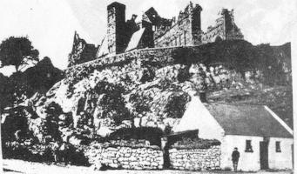

Ruins of the Rock of Cashel in Tipperary

2. BRIAN "COAT OF ARMS

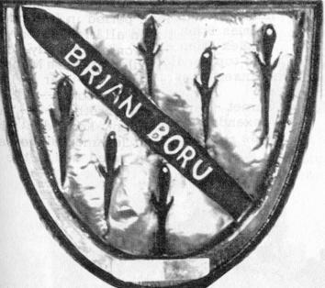

King Brian, ruler of Munster, Ireland, 1002 AD. This Coat of Arms was made out of, brass or copper. The center in the shape of a spear pointed in a diagonal position dividing the Polyhedral figure. The daggers indented in the Coat of Arms in the lower-left and upper right-hand positions represent his six sons.

1. On bottom reading from left to right upward:

Charles Brian - born in May
Morgan Brian - born in January
William Brian - born in June

2. On top reading from left to right:

Dessex Brian - born in December
James Brian - born in July
Thomas Brian - born in October

3. On the top handle of daggers a birthstone was inserted as follows in honor of each son:

Alexanderite - June
Emerald - May
Garnet - January
Rose - October
Ruby - July
Zircon - December
The Slaying of King Brian

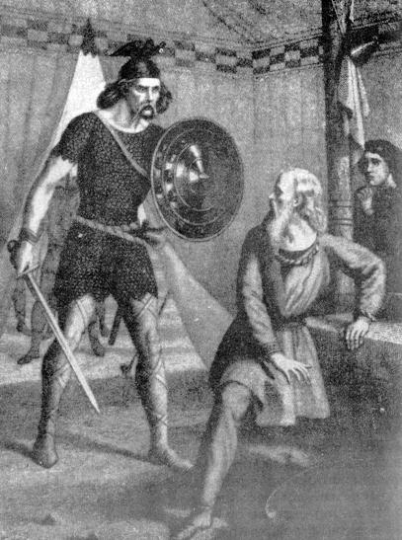

King Brian on his knees in prayer when slain by Bradar, a traitor of the Irish Republic, and by his treacherous wife, Gormlaith.

3. HENRY II

Under the good rule of King Brian the Irish had shown the will and ability to reform their church themselves. Yet, in 1155 AD, Pope Adrian IV (an Englishman) conferred on Henry II of England (ruled 1154-1189) the lordship of Ireland under the impression, given him by Henry, that this was necessary for the cure of Ireland's ecclesiastical ills. Henry went to Cashel, Ireland, where he summoned an ecclesiastical council to reform the church, to make Roman Catholicism the one and only religion; however, this aroused widespread Irish hostility. Because of the Protestant rebellion against such a move, Henry had many of the Brian kinsmen and others put to death. Many fled the island and went to Denmark, Scotland, and Holland.

The gloom of popery had overshadowed Ireland from its first establishment there until the reign of Henry VIII when the rays of the Gospel began to dispel the darkness and afford that light which until then had been unknown since the days of King Brian. In April 1538, the Pope sent to Ireland (directed to the archbishop of Armagh and his clergy) a bull of excommunication against all that had turned against the mother church (Church of Rome). The bull pronounced a curse on all of them, and theirs, who should not, within forty days, acknowledge to their confessors that they had done amiss in so doing.

Dear reader, this conflict is still raging today in old Ireland, between the Catholics and the Protestants. Ireland is still trying to find freedom of worship, with which we in America are blessed and many regard as something worthless.
4. QUEEN MARY

I find very few particulars as to the state of religion in Ireland during the reign of Edward VI, but then Queen Mary, known better as Bloody Mary, came to the throne in England, 1553-1558. Towards the conclusion of the barbarous sway of this relentless bigot, she attempted to extend her inhuman persecutions to this island; but her diabolical intentions were happily frustrated in the following providential manner. Mary had appointed Dr. Pole (an agent of the bloodthirsty Bonner) one of the commissioners for carrying out her barbarous intentions into effect. When Dr. Pole arrived at Chester with his commission, the Mayor of that city, being a papist, waited upon him; when the doctor, taking out of his cloak bag a leather case, said to him, "Here is a commission that shall lash the heretics of Ireland." The good woman of the house being a Protestant, name of Mary Brian, and having a brother in Dublin, was greatly troubled at what he said. But watching her opportunity, while the mayor was taking his leave and the doctor politely accompanying him downstairs, she opened the box, took out the commission, and in its stead laid a sheet of paper with a pack of cards and the knave of clubs at the top. The doctor, not suspecting the trick that had been played him, put up the box and arrived, with it, in Dublin in September 1558.

Anxious to, accomplish the intentions of his "pious" mistress, the Queen, he immediately went to Lord Fitz-Walter, at that time viceroy, and presented the box to him; which, being opened, nothing was found in it but a pack of cards. This startled all the persons present. His lordship said, "We must procure another commission; in the meantime let us shuffle the cards."

Dr. Pole, however, would have directly returned to England, but he received word that Queen Mary was dead.
5. MARTYRS

A letter dated May, 1558, sent from Rome and directed to O'Neal, sent many Protestants to their death and others in a big hurry to leave the Island. Not long after Mr. O'Neal received this letter he had Thaddy O'Brian, an Irish bishop of Cashel, made a prisoner. He was a direct descendant of Morgan O'Brian, who was the son of King Brian. After examination and search was made, Thaddy O'Brian was pilloried and mistreated in every, way until the king's orders arrived in what manner he should further be disposed of. But orders came from England that he was to be hanged. Rough men laid violent hands on him in his castle in Dublin, and drug him forth to a scaffold at Gallowsgreen where, after being hanged, he hung for some time before burial.

Not long after the death of Thaddy a plot was hatched by the papists for the destruction of the Protestants; and it failed not of the success wished by its malicious and rancorous projectors. The design of this horrid conspiracy was that a general insurrection should take place at the same time throughout the kingdom, and that all Protestants, without exception, should be murdered. The day fixed for the horrid massacre was the twenty-third day of October 1641, the feast of Ignatius Loyola, founder of the Jesuits; and the chief conspirators in the principal parts of the kingdom made the necessary preparations for the intended conflict. The plot was discovered by Owen O'Connelly. Owen had married Helen Brian, daughter of Thurmond Brian, of Dublin.

Even with the discovery of the plot, the bloody part of the intended tragedy was past prevention. The Catholics were in arms on the day appointed, and every Protestant who fell in their way was immediately murdered No age, no sex, no condition was spared.
6. WILLIAM, CHARLES, AND JAMES BRIAN COME TO AMERICA

Wars of conquest were renewed; native princes of the Brian family were killed, forced to flee the country, or to be executed. Many went to Denmark or to other countries. Many were taken to England as prisoners or hostages and after a period of time allowed to settle as private citizens.

In the year of 1640, three young brothers, Charles, James and William left Ireland and came to America. They settled on the Chesapeake Bay in the state of Maryland. Mattie Liles Carpenter, a granddaughter of Thomas and Narcissus Camp Brian, saw the old Brian home there on the Bay, still standing, in the year of 1938. She said the old house was over two hundred years old.

William spelled his name Bryan. He was the grandfather of William Jennings Bryan. He married into the famous family of Jennings.

James Bryan (note he spelled his name with a "Y") later moved to Virginia and then to North Carolina. He had a son, John Alexander Bryan, who married Mary Oliver. They had a son named Robert Thomas Bryan, who was a Missionary to China for over fifty years. Dr. F. Catharine Bryan, his daughter, wrote a history of her father's work entitled "His Golden Cycle." Dr. R. T. Bryan was married to Lulu E. Freeland of Durham, North Carolina, on August 20, 1885.

[note: I have not been able to confirm the existance of Charles, James or William]

I now turn to Charles Brian, who stayed with the original way of spelling the name. He left the Cape Fear country and came to Raleigh, North Carolina, where he met and married Mary McMaster of Scotch descent. They moved to York, South Carolina. They had several children, but only one will I name, Thomas Brian, my own great-grandfather. He married Narcissus Camp, daughter of Sarah Jennings and James Camp. Soon after their marriage they moved to Inman, South Carolina, and settled on the western side of the Pacolet River, in upper Spartanburg County.

[note: Thomas Brian’s father was James Brian, Sr.]

7. THOMAS AND NARCISSUS CAMP BRIAN

In Raleigh, North Carolina, Thomas met and won the hand of Narcissus Camp. I wish I could have met this wonderful woman. I have read and heard of her all my life.

Soon after the wedding they moved to South Carolina and settled on the western-side of North Pacolet River at Camp's Bridge and planned to grow corn and tobacco. They sold their trained Negroes before they left and bought African Negroes. They also brought the first wagon over in this section.

Thomas was the son of Charles and Mary McMaster. He was very successful as a farmer until the Civil War and the freeing of the slaves. I am not certain, but I was told that he owned some forty-to-fifty. When I visited the old plantation home in February of 1958, old Aunt Mary Brian, at that time 108 years old, was still living, one of the many slaves freed by the war. Also, the plantation home was still standing. See picture on another page. Also, I drank water from the old hand dug well, dug no doubt by slave labor. It was lined with rock from bottom to top. The water was so cold and tasted very good. See picture of well.

[note: no documentation for Charles or Mary McMaster have been located to date]

Thomas and Narcissus had seven children: James married Sallie Mooney; Mary married William Foster; Martha (or Aunt Matt) never married; Moses died of typhoid fever in Georgia;

Jane married Henry Liles of Green Creek, North Carolina; John Thomas, no record of whom he married, but he and all his family drowned in the Galveston, Texas, flood in 1900. Alfred Aaron married Mattie McDowell; this is my own grandfather and grandmother.

[note: John Thomas (Joe Thomas in the original printing) was found in Texas, alive and well in the census records that followed the great flood ]

If you wish to know more about other children of Thomas and Narcissus Brian read the next article, "Kinsmen Who Live in South Carolina and Elsewhere."
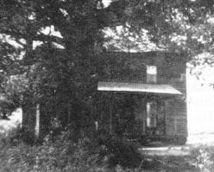

The plantation home of Thomas and Narcissus Brian.
Their seven children were born here.

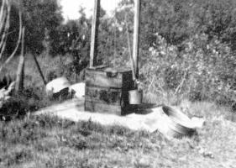

Picture of the old well. "And Isaac digged wells of water..." Genesis 26:18.
Thomas Brian dug this well some time back.
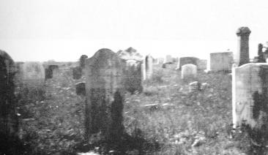

The tombstones of Thomas and Narcissus Brian are located in the New Prospect Baptist Church Cemetery. Thomas' headstone is in the center and Narcissus' to the left. Thomas was b. 1776, d. 1871.

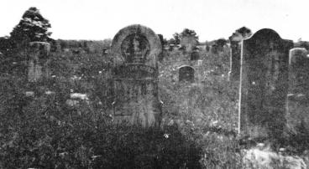

The headstone of Martha Brian (Aunt Matt) reads: b. April 12, 1824, d. May 26, 1908. "For the Lord himself shall descend from heaven with a shout, with the voice of the archangel, and the trump of God; and the dead in Christ shall rise first."

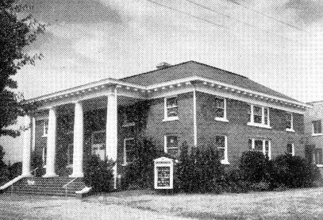

Picture of New Prospect Baptist Church.

Thomas Brian furnished the sawmill that sawed the lumber that built the first Baptist Church at New Prospect. Grandma Narcissus Brian gave the pulpit Bible. It was built in 1820. Thomas Brian also furnished a good bit of the lumber to build the church but we do not know how much.

8. KINSMEN WHO LIVE IN SOUTH CAROLINA AND ELSEWHERE

Jane Brian married Henry Liles of North Carolina. Jane was a sister to Aaron Brian, my grandfather, and daughter of Thomas and Narcissus Brian. They had four children as follows

1. John Belton Liles, m. Annie Dean of Spartanburg, South Carolina. No children.

2. Della Narcissus Liles, m. Bryson Sylvester Reid of Campobello, South Carolina. They had four children

a. Jennie Liles Reid, m. Larry Langston of Spartanburg, South Carolina. No children.
b. Bessie Reid, m. Tom Bean of Springfield, South Carolina. No children.
c. Mattie Reid, m. John Washington Watts of Lourens, South Carolina.
John Washington Watts and wife served as Southern Baptist missionaries to the Holy Land, Jerusalem, for several years. They had four children: Reid was killed in World War II over Greece in a flying mission. John is a missionary in Zurich, Switzerland, and is teaching Hebrew in the Baptist Seminary; m., three children. Betty Jane, m. Elmer West, and he works for the Foreign Mission Board, Richmond, Virginia.
d. Bryce Reid is married and lives in Milan, Michigan, or did a few years ago.

3. Floyd Lannas Liles, m. Carrie Bryan (no kin). They had two children, Bryan and Virginia.

a. Bryan had two daughters, both married, no addresses.
b. Virginia, m. John Scriven, no children. They live on Popular Street in Spartanburg, South Carolina,

4. Mattie Lelia Liles, m. John Sidney Carpenter of Lincolnton, South Carolina. They had four boys and four girls

a. Delia Liles, m. Charlie Jones Stover from Kershaw, South Carolina.

b. Margaret , m. Ben Cook of Greenville, South Carolina. One son, Benjamin, lives in Denmark, South Carolina.

c. Mattie Lelia, m. Dr. Joe Scott and they live in Saint George, South Carolina. One adopted son, Billy.

d. Henry Liles

e. Noah Frank

Henry and Noah are twins and both are orchardists and live on the Carpenter home place and farm it.

f. Julian Belton also lives on the home place with twins near Landrum, South Carolina.

g. John Sidney, m. Margerite Schaen of Cleveland, Ohio, He is a Professor of Industrial Education at Virginia Polytechnic Institute, Blocksburg, Virginia. They have one son, John Sidney III.

James Brian (son of Thomas and Narcissus Brian), m. Sallie Mooney. They had three girls and four boys. I will name the girls first:

1. Emmily m. Adolphus Alonzo McKinney of Asheville, North Carolina, a son of J. M. and Martha Daniel. They moved to Texas in 1869. Bought a farm and built a house on it at Birdstown, Texas. Here they reared their family of eleven children, six boys and five girls:

a. Eddie Lee, b. September 18, 1870, d. November 22, 1945
b. Jessie Earl, b. October 26, 1868, d. May 4, 1956
c. Sarah Martha (Mattie), b. April 6, 1873
d. Carrie Elizabeth, b. April 10, 1875, d. January 11, 1955
e. Nannie Lidell, b. March 11, 1877
f. John James, b. August 29, 1879
g. Walter Brian, b. December 14, 1881
h. Robert Ira, b. June 15, 1884, d. June 6, 1957
i. Lula Eliza, b. January 4, 1887
j. Claud Abbot, b. July 26, 1890
k. Emma, b. August 11, 1893, d. June 13, 1894

2. Charlotte Lou Brian, m. Joseph Hammett and did live near Spartanburg, South Carolina. They had nine children:

a. Etta McCallaster
b. Eliza Cantrell
c. Drusilla McMillin
d. Sally Hall
e. Anna
f. Joe
g. Spurgeon
h. Dock
i. Della Moore

3. Eliza Brian, m. a Willis, and also live near Spartanburg, South Carolina, They had nine children.

a. Dan
b. Will
c. Jim
d. Perry
e. Seila Sloan
f. Eula McDowell
g. Estell Brown
h. Ada Brannon
i. Lizzie Baughcome

4. William (Bud) Brian, m. Martha Walker. They had eight children.

a. Spurgeon, m. Minnie Lowe
b. Thomas
c. Jerome
d. Sally Edwards
e. Ema Ramsey
f. Louie
g. Mattie Sue McDowell
h. Nellie Alverson

5. Spurgeon Brian, m. Seny Ann Royston. They had four children.

a. Mooney Royston m. Carrie Mae Johnson
b. Perley Blanche Brian Brown
c. Mattie Narcissus Brian
d. William Earl m, Maggie Burnett

6. John M. Brian, m. Melissa Moore. They had five children.

a. Howard
b. Adolph Brian
c. Ruth Reid Brian - deceased.
d. Margaret Taylor Brian - deceased
e. John

7. Jim Brian, m. Canvass Brian, They had five children.

a. Daniel
b. Boyce
c. Monti
d. Lily
e. Pearl Jim Brian lived at East Flat Rock, North Carolina.

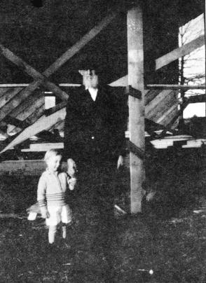

Picture of Spurgeon Earl Brian, son of James M. Brian, and grandson of Thomas Brian. The small boy is his grandson, Brian Brown, the son of Blanche Brian Brown.

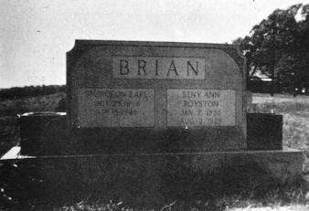

Spurgeon Earl Brian and Seny Ann Royston Brian

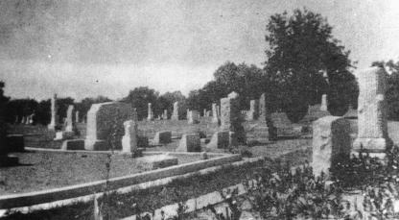

Picture of Church Cemetery, New Prospect

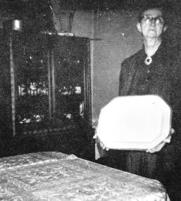

This belonged to our great grandmother, Narcissus Camp Brian. This turkey platter is over 150 years old and was sent by a kinsman from Scotland. Blanche Brian Brown is holding it. She is the daughter of James and Sallie Mooney Brian, and great-granddaughter of Narcissus Camp Brian.

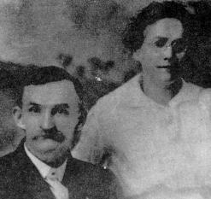

Mr. and Mrs. Jim Brian

Jim was a son of James M. and Sallie Mooney Brian, and grandson of Thomas and Narcissus Camp Brian.

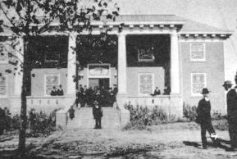

This is the picture of the New Prospect Baptist Church after it was remodeled. The old church burned. Thomas and Narcissus Brian were saved and baptized into this church. This is the church where my grandfather, Alfred Aaron Brian, found the Lord and was baptized. just east or to the back of the church is the cemetery where many of our kinsmen are buried. I visited the graveyard in 1957 and then in 1970.
9. ALFRED AARON AND MATTIE McDOWELL BRIAN

I suppose the first time I can remember seeing my grandfather and grandmother named above was in 1920 when they came to Estacado, Texas, to live with us. Grandmother died in the summer of the same year and grandfather lived with us off and on until he decided to go to the Confederate Home at Austin, Texas, in the year of 1925. In 1928 1 went to Austin for a track meet and visited with him for the last time. He passed away in 1932 and his body was carried back to Gorman, Texas, where he was given a military service and buried by the side of his beloved wife. See head markers on another page.

Alfred Aaron Brian was born in Spartanburg County, South Carolina, in 1837. He had three brothers and three sisters. Joe Thomas, Moses, James, Mary, Martha and, Jane. He grew up with plenty and didn't have to work. His father had several Negro slaves and his children were brought up with little to do, other than go to school and have a good time. Aaron finished high school and had some college work. He taught school sometime after the Civil War.

The Old Brian Plantation was on the western side of the North Pacolet River. Across the same river on the eastside was the Ossie McDowell plantation. He had several children, one by the name of Mattie, very beautiful but like her intended husband, Alfred Aaron, reared not knowing how to do anything. I have heard her tell about the hard times she had of doing things for her family after the slaves were freed. Sometime about 1861 or 1862, during the war, they were married.

A. A. joined for duty and was enrolled at Spartanburg, April 13, 1861; was mustered into Confederate service at Orangeburg, June 4, 1861; absent on sick leave August, 1861; in C. A. S. General Hospital, Charlottesville, Virginia, with typhoid fever as reported by Surgeon Thompson. Reported on muster roll of December 31, 1861, as present; promoted to 2nd Sergeant, February 28, 1862; then promoted to Ist Sergeant sometime between February 28 and June 30, 1863. He was a member of Co. E, 5th Regt. South Carolina. Please note his Confederate papers on another page.

I can recall the memoirs of my grandfather as he would tell and relive them. His first war engagement was in the battle of Bull Run. The Confederate forces were entrenched at Bull Run Creek, a tributary of the Potomac. On July 21, 1861, General Joseph E. Johnson, Confederate Commander, was attacked by General McDowell. The Confederate forces fell back in confusion and appeared to be defeated. But they rallied when someone, pointing to General Jackson and his men standing before the Federal advance, cried, "See where Jackson stands like a stone wall. Rally around the Virginians. Let us determine to die here and we will conquer."

Thenceforth, Gen. Thomas J. Jackson, one of the great southern generals, was known as Stonewall Jackson. The Confederate troops pressed forward and the Federal troops, panic-stricken, fled from the field in a complete rout. There had been great enthusiasm in the North over the prospect of this battle and a vast crowd had come out from Washington to" see the Rebels run." These spectators jointed the Federal troops and didn't stop until they reached the Capital. I can still hear grandfather chuckle as he would relate this battle.
After the above battle the two armies remained facing each other for nearly a year and they both occupied the time in drilling their troops into effective fighting forces, Hence, why grandfather's furlough in October until December 3, 1861.

Then he would recall the Seven Day Fight around Richmond, June 2 5 to July 1, 18 62. This was one of the most terrible battles of the war. Gen. Lee lost nineteen thousand men and Gen. McClellan lost sixteen thousand Federal troops.

Grandfather would almost be shouting as he recalled the Second Battle of Manassas. Gen. Lee attacked Gen. Pope on the old battleground of Bull Run and drove him and his men from the field. For the second time the victory smiled upon the Confederates at Manassas.

Then he would go to the next battle of Fredericksburg. (I visited this battlefield in 1970. I could feel that I was on hallowed ground.) This battle took place December 13, 1862. The Federals lost 12, 653 men, and the Confederates lost 5,309. The night of December 14 was very cold and grandfather was very tired and sleepy. He pillowed his head on a log and went to sleep. When he awoke the next morning Confederate buddies were laughing at him. He got up and discovered that his supposed log was none other than a dead, frozen Federal soldier.

In the spring of 1863, on the second day of May, came the battle of Chancellors ville. It was a brilliant victory, but also a dear one for the South, for it cost them the life of Gen. Stonewall Jackson. Gen. Jackson and some of his men had gone out to view the battlefield and to make plans for the next day. When they came back to their camp it was foggy and they were taken for Union horsemen and fired upon by the Confederates, and Stonewall Jackson was mortally wounded. Grandfather then would say, "The South would have won the war if the life of Jackson hadn't been lost." This battle cost the Federals more than 17,000 men, while the Confederates lost about 12,000 men.

The two armies met again at Gettysburg July 1. The Union lost twenty-three thousand men, while the Confederate dead numbered twenty thousand. This is the battle where grandfather and his brother, Joe Thomas, were wounded and taken prisoners of war, and held as prisoners until after the surrender of Gen. Lee at Appomattox Court House on April 9, 1865.

One night in May of 1865, grandfather arrived in Spartanburg about twelve o'clock at night. He walked all the way from Spartanburg to the old plantation home and arrived about nine o'clock. He had returned to a ruined and neglected home to take up again the occupation of peace in a land bereft and bare.

After no more slave labor, Thomas Brian divided the plantation land among the children. My grandfather received his land from the southwestern corner of the estate, where he built a house for his already started family. See the picture of the house he built on another page. This is the house where my father, Kleber Dessex, was born and some of his brothers and sisters, namely: Custer, Moses, McDowell, Mollie, Fannie and Nancy, while Jennie was born in Little Rock, Arkansas. Joe and Phila were born in old plantation house.

Grandfather sold out and left South Carolina in November 1884. Kleber Dessex and some of the older boys went by land in covered wagons, while the rest went by rail. They settled sixteen miles west of Little Rock in Plasco County. Next year he moved his family again to Saline County, Arkansas, near Hot Springs. In November 1886, he moved his family to Texas. In December of that year they settled in Wolf City, Texas.

This is where I shall leave my grandfather and turn to the life of my own father, Kleber Dessex Brian.

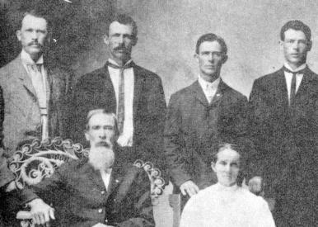

Alfred Aaron and his wife Mattie McDowell Brian and four of their sons from left to right: Tom, Kleber Dessex, Custer and Moses. Their other son, McDowell (Mack) failed to be in picture.

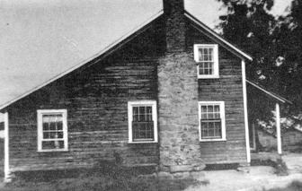

After the Civil War, grandfather came back from prison camp and built this house in 1868. The house was still standing in 1970 when I was back there. Two of their children were born in the old plantation home; see picture of it. Kleber Dessex, Custer, Moses, Mack, Mollie, Nancy and Fannie were born in this house. Jennie was born in Little Rock, Arkansas.

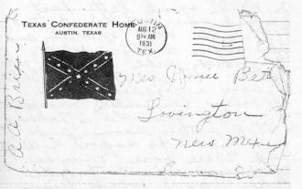

This letter was addressed to Jennie Betts, grandfather's daughter.

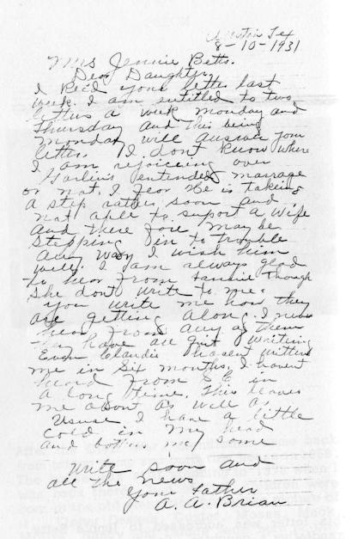
10. MOLLIE BRIAN McGUIRE

Mollie Brian McGuire, the first child of Alfred Aaron and Mattie McDowell Brian, b. 1865, in the old plantation home near Inman, South Carolina. A young Negro slave, Mary Brian, was the nursemaid for Grandmother Brian. She was very dear to Mattie McDowell Brian and when she was freed after the war, my grandmother said, "It hurt me more to give up Mary than any other thing, which I had to give up." Alfred Aaron Brian didn't get to see little Mollie until after the close of the Civil War, as he had been held as a prisoner of war in a prison camp in the state of Pennsylvania.

Mollie Brian McGuire was married to Will McGuire of Spartanburg, South Carolina, in 1882. Sometime later they moved to Little Rock, Arkansas, where they lived until their death and were buried there.

Somewhere about 1898 or 1899, my father, Kleber Dessex Brian, moved his family from Wolf City, Texas, to Little Rock near Uncle Will McGuire. They had words and a fight over a span of mules, so my father ups and moved his family back to Brownwood, Texas. Due to this ill feeling the families never wrote nor visited again. I suppose after the trouble and leaving of Arkansas, neither one saw the other again. For this reason, I have to confess we have no history of this family. No ill will on our part, but going back to our fathers.

11. PHILA BRIAN DUKE HENDRICKS

Phila Brian Duke Hendricks. b. December 16, 1867, in the old plantation home near Inman, South Carolina. She was the third child of Alfred Aaron and Mattie McDowell Brian. She married George Duke, October 22, 1890, at Bonham, Texas. To this union the following children

1. Jo Duke Luker who lives at 407 W. Lillie, Madill, Oklahoma 73446.

2. Carl Duke, Star Route, Box 15 6, Stephenville, Texas 76401.

3. Lynk Duke Martindale, 407 W. Lillie, Madill, Oklahoma 73446.

Phila Brian Duke was married to Henry Clay Hendricks, in September 1896, at Bonham, Texas. To this marriage these children were born:

1. George Hendricks, Boswell, Oklahoma.

2. Helen Hendricks Glass, Boswell, Oklahoma.

3. Herman Hendricks, Boswell, Oklahoma,

4. Clay Hendricks, Boswell, Oklahoma.

5. C. L. Hendricks, 526 N. 2nd Street, Brownfield, Texas,

6. Pat Hendricks, Boswell, Oklahoma.

I have to say again that I don't know too much about the Hendricks family. They lived most of the time in Oklahoma and we lived in. Texas, but I did see some of them a few times in our home and visited with some of the Hendricks boys in Brownfield. We were not close enough for me to tell too much about them.

I can remember Aunt Phila Hendricks coming to our home in 1928 and visiting with her brother, Kleber Dessex Brian, my father. The best I can remember, she was short and heavy, nice looking, and real friendly. I can recall that she and dad had some real good laughs together. She departed this life, December 21, 1963. She lived to be 94 years of age.
12. FANNIE BRIAN TARRY

I called her Aunt Fannie, and she was the dearest one of my aunts. I loved her because she was always jolly and could see the sunshine through the darkest clouds. She-was a good cook and I suppose this had a tendency for me to have the warm place in my heart for her, as all growing young men love good food. Somehow or other boys and men can be reached through the stomach, and most young brides should learn this early. I have been in some homes where the wife kept a poor house and didn't dress the best, but her husband thought her a super duper, and wouldn't give her up for the best-dressed or most elegant housekeeper in the land. Why? Because she has reached his heart through his stomach.

Fannie Brian Tarry, b. 1880, in Inman, South Carolina, to Alfred Aaron and Mattie McDowell Brian, m. Sidney Johnson Tarry, May 1, 1897, at Ladonia, Texas. Sidney Johnson Tarry b. November 1869, near Knoxville, Tennessee, d. August 1940, and buried in Antioch Cemetery. Fannie Brian Tarry d. 1957 in Lovington, New Mexico, and buried also in the Antioch Cemetery.

To this union the following children were born:

1. Luther Calvin Tarry, b. January 30, 1898, m. Bennie Workman, June 21, 1925, Bonham, Texas. They have the following children:

a. Edna Tarry Lambert, her address: P.O. Box 121, Belen, New Mexico.
b. Doris Tarry Chick, she lives in Gallup, New Mexico.
c. Winona Tarry Walton, P. 0. Box 1002, Willcox, Arizona.
d. L. B. Tarry, m. Patricia Tarry, they live in Belen, New Mexico, PO Box 153.
e. Joan Tarry Hay, lives Star Route, Marcola, Oregon.
f. Frank Leroy Tarry, m. Janet Marie Royon. Live in Gallup, New Mexico.

2. Florence Tarry, m. Walter Guy LeCroy, b. Columbia County, Arkansas, 1898. To this union the following children:

a. L. C. LeCroy killed in car wreck during the Christmas holidays, 1967.
b. Irene LeCroy Simpson - two children, Roy Simpson and Diane Simpson Gamble.
c. Virgal LeCroy, three children, Steve, Karon and Mark.
d. Walter Guy LeCroy, Jr. - two children, Gary and David.
e. Florence Nadine LeCroy Jones - six children: Jackie Sanderson Flake, Toni Sanderson, Terri Jones, Chris Jones, Jerry Jones and Gary Jones.
Florence's address: 1717 Wilson, Levelland, Texas.
3. Edna Elnora Tarry Kuchesky, m. June 9, 1928, in Idalou Methodist parsonage.
Four children:

a. Ruth Kuchesky Christoffel, they have two children and live in Pomona, California.
b. Harold Morgan Kuchesky, lives in Macon, Mississippi.
c. Barbara Joan Kuchesky Wright, has four children.
d. Beverly Joyce Kuchesky Campbell, has three children and lives in Amador City, California. Edna's address: 38919 Acacia Lane, Cherry Valley, California. Her mailing address: PO Box A.E., Beaumont, California 92223.

4. Joe Thomas Tarry, m. Hazel Cox, they had three boys and two girls. I only have the names of two as follows: Joe Ellis Tarry, m. and has three children and is a missionary to Brazil. Mrs. Tommie Tarry Hare, they live in Barstow, California, and her husband is a schoolteacher. I know they have some children but don't know how many.

5. Lester Sidney Tarry, m. Beatrice Harralson and they have four children, two boys and two girls. They have a Dr. Kirby B. Tarry, M.D., who lives in Hawaii. I wish I had more information.

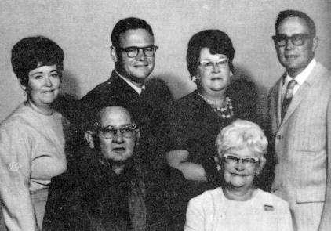

Lester Sidney Tarry and Beatrice Harralson and their four children

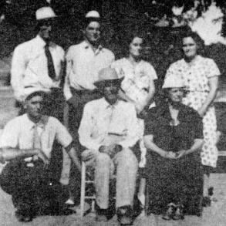

Lester Sidney Tarry, Sidney Johnson Tarry, Fannie Brian Tarry; Back, left to right: Luther Calvin Tarry, Joe Thomas Tarry, Edna Elnora Tarry Kuchesky and Florence Tarry LeCroy.
13. JENNIE BRIAN WALSER

Jennie Brian Walser was born near Little Rock, Arkansas, December 23, 1885, the tenth child and the baby of Alfred Aaron and Mattie McDowell Brian. She died in Lovington, New Mexico, June 10, 1960, and was laid to rest in the Antioch Baptist Cemetery some fifteen miles north of Lovington.

She was married to Earnest Callie Walser on December 5, 1906, at Funston in Jones County, Texas. Earnest Walser was the son of George Walser of Germany.

Jennie Brian Walser had three sons. Garland Walser, born September 23, 1910. He married Laura Gladys Poe at Lometa, Texas, on October 9. 1931. Their children: Marva jean, Jocelyn Marie, Uthal Darel, and Wilma Jannette. Garland lives on Star Route, Evant, Texas 76525. He has been pastor of a rural Baptist church near his home for the past ten years.

Woodrow Wilson Walser, born November 12, 1912, and died of poliomyelitis on February 24, 1923. He is buried in the Gorman, Texas cemetery.

J. B. (Mutt) Walser was born November 10, 1915. His. present address is 1507 Utah, Alamogordo, New Mexico 88310. He was married to Janaria Rose Rogers July 19, 1937, in San Antonio, Texas, in a Baptist church. They have one daughter, Trecia Faye Walser Blancett, born September 17, 1945. (Mutt wrote me he has a grandson, the finest, and a fine son-in-law.) One son, Jerry Brian Walser, born June 7, 1950, Alamogordo, New Mexico. Jerry Brian still at home and single on the date of writing.

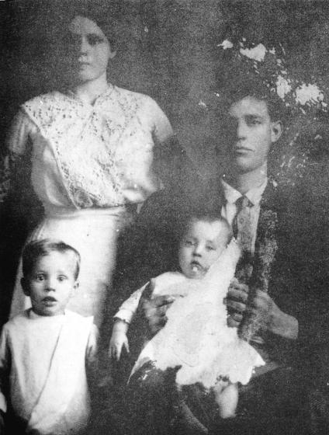

Left to right: U. Garland Walser, Woodrow Walser, Jennie Brian Walser, and Earnest Walser.
14. JOE THOMAS BRIAN

Joe Thomas Brian, b. 1867, in Inman, South Carolina, the oldest son of Alfred Aaron and Mattie McDowell Brian. He married a girl by the name of Mattie and they have a daughter, Hazel, who is married and lives in Ft. Worth, Texas. Both Uncle Tom and Aunt Mattie died and are buried in Ft. Worth. I am sorry that I do not have any more information about Uncle Tom and his family. I hope after this book is published to get in touch with Helen Hazel and we can finish this-history and write it on the pages left for that purpose.

I remember Joe Thomas Brian coming to our home in 1921. He was a very handsome businessman, dressed in a very nice gray suit. He had a little mustache grown on each side of the upper lip which gave him a look of distinction. He was very successful in his field of business as a commercial traveler. I was only eleven years of age when he visited in our home'. This was the first and only time that I saw him, but the memory of a well-dressed businessman has lingered with me through the years.
15. CUSTER BRIAN

General George Armstrong Custer, American Cavalry Officer, famed for his "last stand"' against the Indians. He commanded the 3rd Cavalry Division and served under General Robert E. Lee, and on April 9, 1865, received Lee's flag of truce--a towel- -afterward given him as a present from his commander, General P. H. Sheridan. When the fifth child was born to Alfred Aaron and Mattie McDowell Brian, he was named Custer Brian after the famous General Custer, whom Alfred Aaron Brian had met during the Civil War and appreciated very much.

Custer Brian was born in 1873, Inman, South Carolina, m. Mary Hale Brian. To this union four children as follows:

1. Effie Brian who married Albert Parr. They have one daughter, Willie Mae Jones, who lives in Odessa, Texas. They have one son, J. D. Parr, who lives near Chico, Texas. Effie died in 1970.

2. Nicki Brian, killed by a neighbor over a fence-line dispute about 1928, near Sunset, Texas.

3. Aaron Brian - deceased.

4. Ellis Brian lives in Oklahoma City, Oklahoma. I am sorry but I do not have his address or information about his marriage or family.

I suppose that of all my father's brothers Custer Brian was the most soft-spoken and gentle of all. He would never raise his voice and was always so gentle, kind and loving. When Nicki was killed and Aunt Mary, Uncle Custer's wife, was losing her mind over his death, Uncle Custer was so good to her. She would walk the floor day and night, saying, "Poor Nicki, poor Nicki," and Uncle Custer would never get upset but would talk to her gently and calm her down with his loving voice. Even after Aunt Mary was sent to the mental institution at Wichita Falls, Texas, Uncle Custer was near her as much as he was allowed by the regulations. This continued until the time she passed away. Uncle Custer was a good man, one that loved God and his fellowman. He was called home to be with the Lord in 1969, after living to a ripe old age of 96 years.
16. CALVIN McDOWELL AND IRENE BLUNT BRIAN

Calvin McDowell Brian, b. December 28, 1884, Inman, South Carolina; d. March 15, 1952, Mesa, Arizona, m. Mary Irene Blunt near Stephenville, Texas, 1904. She died June 22, 1962, Quine Creek, Arizona. To this union ten children were born.

1. Willie Afton Brian, b. 1905, d. in 1963 in Kingman, Arizona. I don't know who he married but he has a daughter, Mrs. James Brian Love, 2956 Mobley Street, San Diego, California.

2. Mattie Rebecca Brian Moody, b. 1907, m. Luther Moody, d. 1967 and buried at Truscott, Texas. They had two children:

a. Glenna Louise Moody Green who lives in Abilene, Texas, and has three children: Lois, Rebecca and Paula.

b. Tommy Mark Moody who has three children: Kim, Reda and Brian. Mattie Moody remarried in 1970 to Clyde Bullion and they live in Truscott, Texas 79260, Box 711.

3. Calvin Alfred Brian, b. 1908, lives in Tacna, Arizona. No more information.

4. Kleber Dessex Brian, b. August 13, 1911, m., no children. Address: Box 242, Pixley, California 93256.

5. Marcus Liston Brian, b. June 9, 1913, M., lives on 33rd Street, Fort Worth, Texas. No more information.

6. Alma Mae Brian Strickler, b. May 11, 1915, address: 292 Gene Lane, Fort Worth, Texas, No more information.

7. Charley Weldon Brian, b. March 2, 1918 ~ He is in a Veterans Hospital, Los Angeles, California. No more information,

8. Irene Brian Wakby, b. March 3, 1920. Address. Arcade Building, San Manuel, Arizona. She is in the insurance business. No more information.

9. Lois Louise Brian Jenkins, b. March 1, 1924. Lives in Phoenix, Arizona, No more information.

10. Doris Brian, b. March 1, 1924, d. March 5, 1924.

I suppose I would have to say this about Calvin McDowell Brian, this is the way I remember him. He was short, heavy and stout, and his stomach was made so it rounded out. Late one evening he and his son Calvin drove up to our home at Estacado, Texas, in an open-top "T" Model Ford. This is the first time I remember seeing my uncle and cousin. We had a good laugh as Calvin, his son, told the following incident. That day somewhere, close to the town of Girard, Texas, two boys shot Uncle Mack on the arm. It really hurt him and he cried out, "Stop the car, Calvin I'm shot, I'm shot!" When Calvin stopped Uncle discovered the red place on his arm and realized what had happened and saw the two small boys running with their sling shots. He cried out, "Catch them, Calvin, and I will give them what they need." Calvin couldn't run for laughing, and the boys escaped in the mesquite brush.

He was always very jolly and laughed a lot. The last time I remember seeing him was when I visited in his home at Sylvester, Texas, in 1927. He would pat his stomach, laugh real hearty, and say, "Ted, how do you like my bread-basket?" He and his wife made company welcome and had them to enjoy a hearty meal with them and the family. He was a wonderful person and a joy to be with.

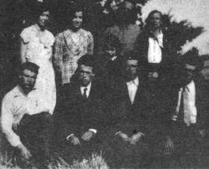

Left to right: Kleber Dessex Brian, Charley Brian, Marcus Liston Brian, Calvin Brian, Irene Brian Wakby, Alma Strickler, Lois Brian Jenkins, Calvin McDowell Brian, and Irene Blunt Brian.

17. MOSES B. AND MINNIE SPIZER BRIAN

One beautiful spring day in the year of 1917, a big shining car stopped at the rock house in which we lived, near Peacock, Texas. I think that all of us, even to the dogs, ran out to see who the occupants were. A good looking man dressed in a nice suit stepped into the yard and came toward us with a big smile on his face. On the other side of the pretty car, a very dark, tall, graceful, young woman with long black hair made her way toward us. This was my first time to see my Uncle Moses and Aunt Minnie. I don't suppose I would have remembered this incident so well but for one thing. My brother and I went to the car to put our hands on it and to see ourselves in the shining surface, when our Uncle Moses came and told us to keep our dirty hands off the car. Well, you see, we didn't get 1, see cars very often, and then just at a distance, and here was one that we could touch and see ourselves in just by looking. I don remember how long they stayed, but I do re member that I didn't get to ride in the car an I would have given all my marbles, even parting with my agate taw, for one little ride in it

Moses B. Brian was born August 10, 1881, in Spartanburg County, South Carolina a son of Alfred Aaron and Mattie McDowell Brian. He died November 24, 1955, in Lovington, New Mexico, and was buried in Antioch Cemetery.

I don't know the date of his wedding. Minnie Spizer Brian was born and reared in the town of Sagerton, Texas, rather on a farm just outside the town. Her family was prosperous Germans. For a wedding gift, her daddy gave her four hundred acres of black land. They sold it and invested it in a hotel and lost all their money in this business at Knox City, Texas. Aunt Minnie died in 1953 and was buried in Las Vegas, New Mexico. If they had children they died in infancy.

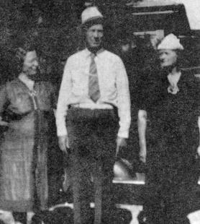

Jennie Brian Walser, Moses B. Brian, and Fannie Tarry Brian, left to right.
18. KLEBER DESSEX AND ELIZABETH MELTON BRIAN

My mother was born in Attala County Mississippi, on May 28, 1871, to Jeff and Miltilda Green Melton, She was the third child born into this home. Joe and Sam were twins, then Mother, John, Dora and Andy ~ In 1880, Grandpa Melton sold his property in Mississippi and moved to Texas and bought a farm in the Whatley community, some six miles northeast of Wolf City. Here he built a nice home for his family (see picture of home).

How shall I describe my mother? Maybe by saying she was ninety-five pounds of pink porcelain, plump as a partridge, beautiful white hair, bearing the loveliest nickname ever given to a woman, "Aunt Patsy. " God fashioned her heart to be gracious, her body to be the mother of children, and as to hear special gift, a gift of grace- the art to cook and entertain company. I have seen her cook for a s many as twenty to thirty people at one meal.

Patsy Brian was the mother of eleven lusty babies, ten of whom she reared to manhood and womanhood. Elmer, the first child: born July 23, 1892, and on March 17, 1893 was burned to death.

I always remember my mother with her long white hair. When she was about thirty years of age she had typhoid fever and her hair came out and when it grew back it was whit(Her hair was white many years before my birth.

Even with a large family to look after she found the time to keep an immaculate house, to set a table renowned in her community, to entertain with unfailing hospitality all who came to her door, to beautify her home with whatever means she could command, to embroider, crochet, and piece quilts. But her greatest gift was conceded by all to be the making of things to grow, at that she was wonderful. She started dainty little vines and climbing plants from seeds, shoots and roots from every source available. Tulips, daffodils, star flowers, lilies, dahlias, hyacinths, petunias, asters, verbena, larkspur, phlox, roses -- well, you name it and she grew it.

Dad and Mother were married on October 2, 1891, at Ladonia, Texas. Three of the eleven children were born near Wolf City, namely Elmer, Cora Bell and Norma Jeff. Dad then decided to move back to Little Rock, Arkansas. Loucille was born there. In 1899, the family moved to Brownwood, Texas, and in 1900 Alfred Aaron made his appearance and joined the clan. Also in this same year a tidal wave arid storm hit Galveston and some 5, 000 lives were lost, among this number Joe Thomas Brian and his family. He was a brother to Aaron Brian, my grandfather.

In 1901 Dad moved his family to Eastland County and bought a place known as the Old Mountain Place. It was here that Melton Dessex Rosa 'Victoria and Walter Lee discovered America. Then in 1908 he bought a place about two miles north of Desdemona (see picture of our home on another page). It was here that the author of this book, William Preston, joined the gang. Being very small but plenty of life, my sisters would dress me up as a teddy bear, hence the nickname of "Ted" which has stuck through the years.

Dock came to live with us in 1913. Really, his name is Dalton Delmont but you will note that a large family is famous for giving nicknames. Then the last one but not the least, Samuel Ellis, made his arrival. By that time Papa and Mama had run out of names. Dr. Snodgrass, the family doctor, asked them, "What are you going to name this fine boy? " When they shook their heads, he replied, "Name him after me!" So he bears the name of a real fine family doctor.

The boll weevil hit the cotton in Eastland County in 1915 and 1916. Hard times faced my dad trying to make a living for a large family. He decided to go west and find a new country. In July of 1916, we left in covered wagons going west. I was old enough then to remember several things, such as eating the good food that my mother and sisters cooked on the open campfire.

We went as far west as Peacock where we lived for two years, which didn't help us any financially as both years a drought cam, and nothing made. In the fall of 1917, we went by wagon to East Texas, near Commerce where we picked cotton. I remember spending Christmas with Grandpa and Grandma Melton near Wolf City. About the first of January we went by train back to Peacock, to our old rock house on the Salt Fork of the Brazos. Another dry year moved us to the high plains. We gathered maize and picked cotton near Plain view and then we moved just north of Petersburg and lived there some few months and the rented a farm between Idalou and Lorenzo where we lived most of the year of 1919. That fall my father bought the place of Mr. Mantooth, near Lorenzo, at Estacado. At least for the younger children, this must have been home more than any other place. All the children spent many happy hours here, even by those who were married and would come back for a visit real often.

We can all say that Mother completely submerged her own life in usefulness and lost her life in countless deeds of service to others. Jesus said, "He that loseth his life for my sake shall find it." Matthew 10:39. This was her purpose. Sacrificially, she surrendered her life to her husband, her children, her grandchildren, and to the needs of others who reached out to her for understanding and compassion. The Lord called her home July 2, 1950, while visiting with Dud at Bronco, Texas. She is buried in Lorenzo Cemetery.

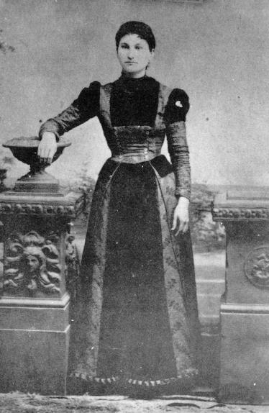

Elizabeth Melton Brian, the author's mother. She was about eighteen when this picture was made and this was two years before her wedding.

The author's father was descended from a long line of ancestors of Irish blood. He was named for and traced his origin back to Kleber Dessex, son of King Boru of Ireland, To his Irish traditions and the customs of the family, Kleber Dessex Brian clung with rigid tenacity, never swerving from his course a Particle under the influence of environment or association. All his ideas were clear-cut, no man could influence him against his better judgment. He believed in God, in courtesy, in honor, and in cleanliness, in beauty, and, most of all, in a good name. The last time I talked to him, just before his death in 1946, he said to me, "Ted, I am not leaving you children any worldly property, but I am leaving you a good name." I have thought of this many times since and of how God's word bears this out. "A good name is rather to be chosen than great riches, and loving favor rather than silver and gold." Proverbs 22: 1.

Kleber Dessex was born on July 5, 1871, at Inman, South Carolina, the third child of Alfred Aaron and Mattie McDowell Brian. He left South Carolina when just a small lad and never returned. I have heard him say that his great desire was to make a trip back to the place of his birth, something he could never do because of the responsibilities of a large family of ten children. I told much of his travel history in with Alfred Aaron Brian, his father, and his wife Patsy, so I won't retell it.

All his life, with no thought of fatigue or thinking of self, Kleber Dessex Brian worked hard to Provide for others. To him the love of God could be shown so genuinely in no other way than to live with Christ in his heart. In the year of 1922, the Baptist Church at Estacado, Texas, laid hands on him and ordained him a deacon, the place he filled with high honor until his death on February 11, 1946, some twenty-four years. I have heard several men say who were his pastors, "Your father is a pastor's friend, you can always count on him."

My father was strict and most of the time very stern. He expected and exacted obedience. He believed that discipline commenced early surrounds a child with safe limits for his growing up. We had as many pleasures as the times accorded. We went occasionally to spend the night with a neighbor or a kinsman. We went sometimes to the small towns near us. A few times our father took us to the county seat town of Lubbock. It was a marvel for our young eyes to see the city, and we would ask our father a lot of questions, which he would always try and answer. Most of all, we went to church whenever there was a service; this came first with my father. I have been asked many times by many, "Was your father a preacher?" I would answer, "No, just a deacon." Then another question, "Then why five preachers in one family?" I would reply, "Our mother and father lived such dedicated lives that we saw the Lord in their living. This is the great reason that the Lord called five as preachers, one as a deacon, and the four girls dedicated to the Lord, good wives to their husbands, great mothers to their children and just wonderful sisters to pray and encourage their brothers in their ministry.

Even before I can remember, my father bought an organ, a wind instrument, to be pedaled by foot. From my earliest recollections, after the evening meal we would gather around it and sing. I had brothers and sisters who could play it, and we would sing the great songs of Zion. I don't ever remember my mother singing, but my father always helped with his great mellow bass voice.

I know now, though our father seemed stern and hard, his love was very deep for his children. I remember when my sister Loucille died at our home in 1927, that my dad was so stunned with her going that for weeks he went around in a daze. In fact, he carried the scar of her death with him to his grave, asking, "Why did we have to give her up?

I never heard my father tell a smutty story, or talk with ill against anyone. Never did one of his children ever hear him swear, or use profane words. His by-word was "Ah-shaw!" I noticed this good quality about my father and all my life I have never taken the name of the Lord in vain, of which I can be thankful.

Our father firmly believed in the teachings of God's word. Especially in this verse Of scripture, "Spare the rod and spoil the child. "--Proverbs 13:24. I believe all the children can vouch that he used the razor strap pretty often. Then we can say that he carried out this old saying, "An idle brain is a devil's workshop," for he could always find plenty for us to do. Hoe, plow, tend the stock, milk, Pick cotton, head maize and dozens of other things.

I always considered my father to be a very handsome man, with his black hair, light skin with a wonderful suntan, and then his smile for one and all. I don't suppose he very often gave a smile where not needed, but whenever someone needed it for a bit of cheer, it was always displayed from ear to ear. My father was not an extra large man, five feet eleven, and weighed about one hundred and seventy pounds. Yes, he was a man among men.

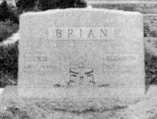

Kleber Dessex and Elizabeth Melton Brian
Lorenzo, Texas Cemetery

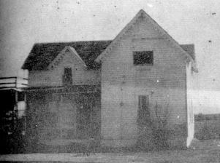

The Jeff Melton home where my mother, Elizabeth Melton Brian, lived from the age of nine until her marriage. I visited my grandparents here several times while a child.

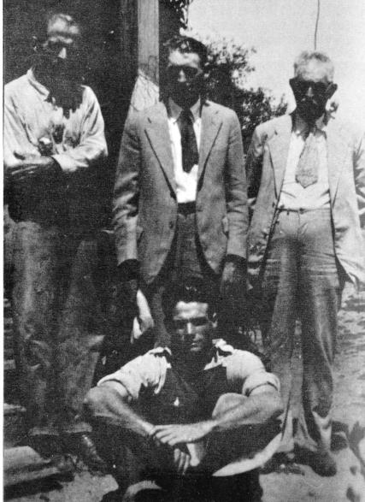

Seated, William Preston Brian, Sr.; Standing, left to right, Kleber Dessex Brian, Anderson Arcemus Howard, and his father, Alexander Portman Howard. Picture made in 1927.

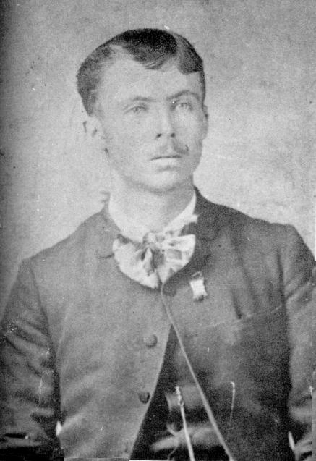

Kleber Dessex Brian, made some time before his wedding. He was about twenty. Father of the author.
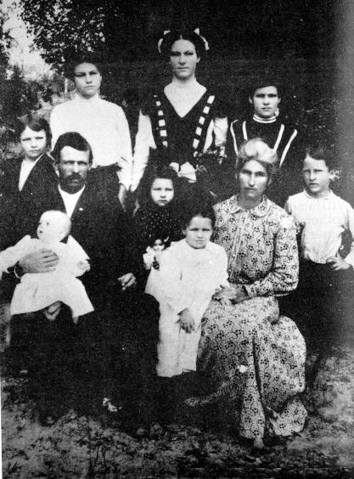

Left to right: The baby, William Preston; Kleber Dessex, the father; Rose with the doll, Walter Lee, with hand in mother's; just to back of mother is Melton Dessex; back of my father, Alfred Aaron II; next to him, Norma Jeff, Cora Bell and Loucille.

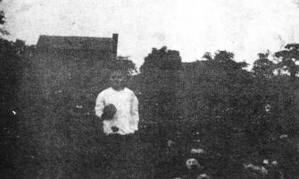

William Preston Brian in flower garden of his mother, Elizabeth Melton Brian. This was the house where I was born, two miles north of Desdemona, Texas.

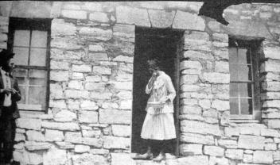

The old rock house that Kleber Dessex Brian family lived in on the Salt Fork of the Brazos River, Peacock, Texas. Loucille Brian Evitt standing in door, Melton Dessex to one side.

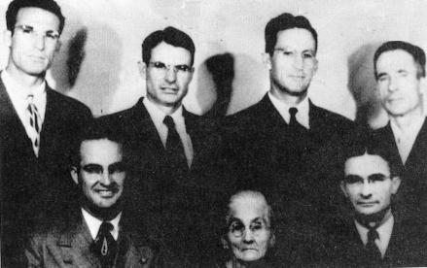

From left to right
Seated: Samual Ellis, Elizabeth Melton and Alfred Aaron Brian.
Standing: Dalton Delmont, William Preston, Walter Lee and Melton Dessex Brian.

All of them became preachers except Melton Dessex and he became a deacon.
Picture made August 1948.
19. CORA BELL BRIAN GREENHAW

"Someone has said that a beautiful young girl is an accident of nature, but a beautiful older woman is a work of art." I believe that she is both. Her perfectly proportioned features were once enhanced by long black hair, but now short white hair adds aristocracy rather than age to her face. Her neck was always long, and she has always held her head high, but with a trace of pride, as if to say, "I am the daughter of a king." This is my way to describe my oldest sister.

Cora Bell Brian, b. August 30, 1894, Fannin County, Texas. She was the second child of Kleber Dessex and Elizabeth Melton Brian. On May 28, 1916, she was married to Walter Franklin Greenhaw at Desdemona, Texas. His parents were Arthur Lee and Laura Meeks Greenhaw and grandson of William A. and Lucinda Phelps Greenhaw. Cora Bell and Walter have two sons:

1. Henry Ford Greenhaw, b. March 19, 1917, Desdemona, Texas, m. Mabel Mabry, daughter of Royal Quinn and Lula Lester Mabry. Ford and Mabel have two children:

a. Mabry Greenhaw, b. January 12, 1940, m. Darla Williams and to this union three children: Melissa Kay Greenhaw, March 4, 1962; Michael Jay Greenhaw, b. January 17, 1964; and Marlon Clay Greenhaw, b. December 29, 1970.

b. Nancy Greenhaw, b. January 14, 1946, m. Jack Dean Collum, August 5, 1967. One child. Shelley Renee Collum, b. May 8, 1971.
(Let me add a word here. I performed the marriage ceremony for Ford and Mabel and thirty years later I married their daughter, Nancy to Jack Collum.)

2. Billy Jeff Greenhaw, b. December 23, 1926, Estacado, Texas, m. Dorothy Huffman, Desdemona, Texas. Born to them two children:

a. Linda Greenhaw Allen. Their address: Box 133, Ranger, Texas.

b. Morris Ray Greenhaw, b. September 12, 1946, Desdemona, Texas, m. Doris Albright, November 29, 1968. They have a daughter, Diana Rhea Greenhaw, b.December 23, 1969.

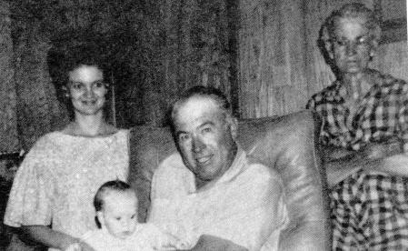

Left to right: Nancy Greenhaw, Shelley Renee Collum, Henry Ford Greenhaw,
and Cora Bell Brian Greenhaw. Four generations in this picture.

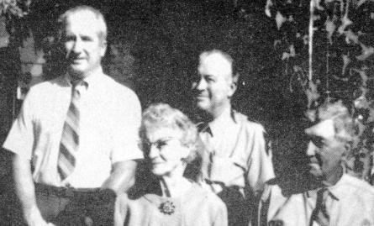

Left to right: Cora Bell Brian Greenhaw, Walter Franklin Greenhaw,
Billy Jeff Greenhaw, and Henry Ford Greenhaw.

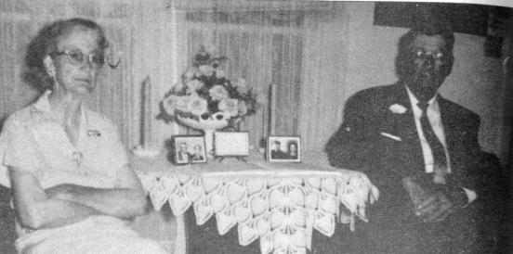

The fiftieth wedding anniversary of Walter Franklin and Cora Bell Brian Greenhaw.
Memories of the wedding performed by Rev. Jim Bayes, Lingleville, Texas.
20. NORMA JEFF BRIAN BRISCO

Norma Jeff Brian Brisco, b. February 11, 1897, Wolf City, Texas, the third child of Kleber Dessex and Elizabeth Melton Brian, She was m. to John Franklin Brisco, the son of William David and Emily Mayfield Brisco. The date of the wedding was June 6, 1915, in Eastland County, Texas. To this union the following children were born,

1. Lonetta Gay Brisco, b. March 31, 1916, Married to Wilson Kittrell. They have one daughter, Jeffie Ann Brisco Rainwater, and she has one daughter, Robin Rainwater. Their address: North Star Route, Lorenzo, Texas.

2. Norma Lou Brisco, b. July 9, 1927, in Lubbock, Texas, m. Melvin Childs, November 28, 1946, in Morton, Texas. Their address: 4903 W. 17th Street, Lubbock, Texas 79416. They have two daughters, Judy Childs Schilling, address: 1725 Seminary Drive, Ft. Worth, Texas; and Debra Childs of the home.

3. Elna Joyce Brisco, b. June 23, 1929, in Lubbock, Texas, m. Bill Greenhill. They have one daughter, Sandy Hill. They live at 3 712- 61 st Street, Lubbock, Texas. 79413.

4. Nelda Frank Brisco, b. May 6, 1933, Lubbock, Texas, m. Francis Shiflett, December 30, 1950, in Morton, Texas. They have two girls and two boys:

a. Terry Shiflett, b. September 4, 1951, Lubbock, Texas.
b. Vicki Shiflett, b. Morton, Texas, February 21, 1954.
c. Dale Shiflett, b. February 6, 1958, Lubbock, Texas.
d. Gary Shiflett, b. August 12, 1959, in Lubbock, Texas.

Their address: Box 247, Hatch, New Mexico.

I think it was love at first sight when John Franklin Brisco saw Norma Jeff Brian. He knew she was the only woman he would ever take as a wife.

I suppose it is the custom for one writing about his sister to say that she was fair and beautiful, but in the case of Norma, there could be no doubt that she deserved everything which has been said about her, that she was one of the most beautiful brides. She had snow-white skin, soft black hair, and eyes of a dusky enchantment. Moreover she was very talented. She could sew and do all things with charm that a young wife had to do to keep house. -With all this she was a good cook. When Norma saw John Franklin her eyes were for him and no other. He was a commanding figure in his nice dress. His hair was real light and his skin very fair. They have lived a happy married life for over fifty years, knowing that God just made them for themselves. God has richly blessed the home with four wonderful daughters, that in return have been a blessing to their husbands, children and all those who come in contact with them.

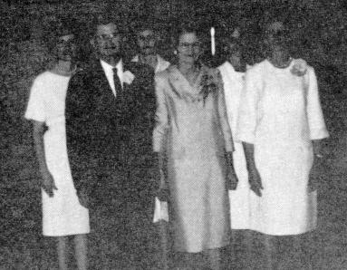

Front, left to right: John Franklin Brisco, Norma Jeff Brian Brisco, Lonetta Brisco Kitrell.
Back, left to right: Nelda Frank Brisco Shiflett, Joyce Brisco Greenhill
and Norma Lou Brisco Childs.

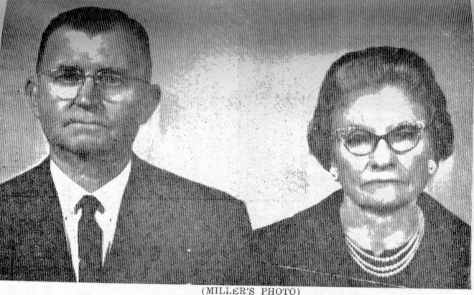

MILLER'S PHOTO
Mr. and Mrs. J. F. BRISCO Observe their 50th Wedding Anniversary
Open House honoring Mr. and Mrs. J. F. Brisco on their Golden Wedding Anniversary will be held Sunday, June 6, at the County Activity Banquet Room, 200 West Taylor in Morton. Mr. and Mrs. Brisco lived in Morton for several years before moving to Stephenville in 1955. Their present address is 1070 Isla, Stephenville. They were married on June 5, 1915 in Desdemona. Friends. are invited to call from 2 until 4 p.m. and the hostesses for the occasion will be their children: Mrs. Wilson Kittrell of Lorengo and Mrs. Melvin Childs of Lubbock. Sharing the hosts duties will be their eight grandchildren. Cards from their friends will be appreciated.
21. LOUCILLE BRIAN EVITT

Loucille Brian, b. December 18, 1898, Fannin County, Texas, m. Charles Wesley Evitt, Sr., December 22, 1920, at Idalou, Texas. The following children were born to this marriage:

1. Esther Cleo Evitt, b. February 12, 1923 Estacado, Texas. Cleo married Andrew Harrison Hendricks, March 8, 1938~ Two sons survive, namely. Andrew Wesley Hendricks and Charles Harrison Hendricks, who live somewhere in Arkansas.

Esther Cleo Evitt married A. L. Yoakum, Reno, Nevada. To this marriage one son, Alvin Russell Yoakum, b. July 25, 1947, diedAugust 11, 1963. Esther Cleo Evitt m. a Mr. Woods in 1963 and since then he has passed away. Her address: Mrs. Esther Cleo Woods, 6439 West Myrtle Avenue, Space 144, Glendale, Arizona 85301.

2. Pauletta Evitt, b. July 2, 1925, Estacado, Texas, m. John Henry Harris, Tucumcari, New Mexico, April 17, 1943. They have the following children. Faye Harris, m. and two children and they live in Bartlesville, Oklahoma. Gretta Lucille Harris, who at this time is attending Oklahoma Christian College, Oklahoma City, Oklahoma. She will be married in March of 1972. Pauletta Evitt Harris, address: 1949 Schaller Court, Topeka, Kansas 66608.

3. Charles Wesley Evitt, Jr. , b. June 3, 1927, at Estacado, Texas, m. Setsu Evitt, and to this marriage the following children: Charlotte Evitt, Esther Cleo Evitt, Fred Evitt, and Linda Sue Evitt. Charles Wesley Evitt, Jr. , address: 1698 Hilton Street, Seaside, California 93955.

Loucille Brian Evitt died June 17, 1927. A few years after her death I wrote the following poem as a memorial to her.

LOUCILLE IS JUST AWAY

I cannot say, I will not say, that Lou is dead.
She is just away!
On June 17th, 1927,
She went home, to heaven, with a cheer smile,
And a wave of the hand,
She made her journey into the better land.
So let us think of her faring on, as dear, in the love there as the love of hers here
She resteth now. No more her breast heaves,
With its weary breath;
Pain sits no longer on the brow, where lies the calm of death.
Sunk to her rest like a tired mother,
She lies in slumber deep, softly folded in the arms of Him, who "giveth His beloved sleep.

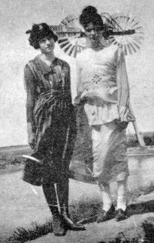

Left to right: Rosa Brian Howard and Loucille Brian Evitt.
This picture made in 1919 at Estacado, Texas, at the twin windmill.

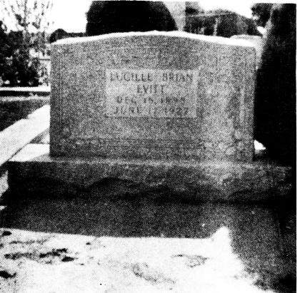

Headstone - Loucille Brian Evitt
"Sleeping, but not forgotten"

After Loucille's death, a few months later Charles Wesley Evitt, Sr., m. Clara Reagan Evitt, February 28, 1928. To this union one daughter, Verna Mae Evitt, who married Wayne G. Parks and they have one daughter, Vickie Parks. Verna Mae Evitt since remarried to Levi Coleman and they live in Fallon, Nevada.

In 1966, Clara Reagan Evitt died and Charles Wesley Evitt, Sr. married Ada Rudd Evitt in November, 1968. Their address: Route 4, Box 82, Clovis, New Mexico 88101.

I conducted the funeral for Alvin Russell Yoakum at Lorenzo, Texas, in 1963. He was the son of Esther Cleo Evitt, so this poem was written to his memory.

ALVIN

Barely seventeen, but why should we want to call Alvin back?
To this earth's wearisome now?
For glories immortal encircle his brow,
From glory to glory, forever ascending,
His soul with eternity forever blending.
In Bakersfield, California, he was saved,
And in Lorenzo, Texas, you can see his grave.
At Firebaugh, California, he finished his race,
But there in heaven we will see his face.

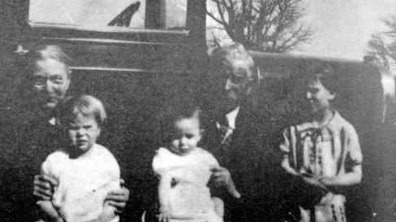

Left to right: Mrs. Evitt, Pauletta Evitt Harris, Charles Wesley Evitt, Jr.,
Mr. Evitt, and Esther Cleo Evitt Woods.

Mr. Evitt was a Church of Christ minister. These are Charles Wesley Evitt, Sr., his parents.

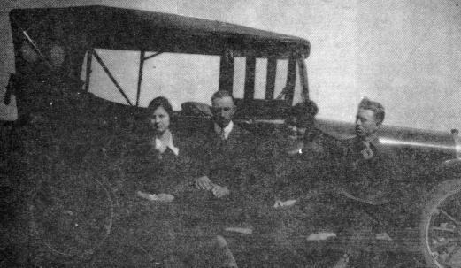

Left to right: Charles Wesley Evitt, Loucille Brian Evitt, and some kinsmen of Charles'.

They are seated on the running board of their 1919 Dodge Brothers touring car. This picture was made in 1920, a short time before their wedding.
22. ALFRED AARON II AND ORA DOPSON BRIAN

"And they journeyed toward the sun-rising." This scripture which was read by Rev. C. M. Spalding at the funeral of Dr. A. A. Brian was typical of the late missionary's philosophy of life. He was a man who was optimistic to the approach of the many problems which confronted him daily. Once he was convinced of the way he should go there was never any shadow of wavering. He was counselor and friend of every pastor and church in the places where he worked. He only served eighteen months as City Missionary in San Antonio and the Baptists experienced a great growth in this length of time.

"He fought a good fight, he kept the faith, henceforth, there is laid up for him a crown of righteousness." These words from the Holy Bible characterize the life led by Alfred Aaron Brian II and the work he accomplished while here on earth. He was open and aboveboard in all his dealings with his fellowman and had the same humility of spirit as would be found in the Apostle Paul.

Alfred Aaron Brian II, b. January 14, 1900, in Brownwood, Texas, the fifth child of Kleber Dessex and Elizabeth Melton Brian. He M. Ora Lee Dopson on March 15, 1925, in Ropesville, Texas. To this marriage the following children

1. Alfred Aaron Brian III, b. December 18, 1931, m. Barbara Branson, Salinas, California, August 6, 1952. Ceremony performed by Dr. Alfred Aaron Brian. Al, as we called him, was called to his heavenly home March 8, 1959, Ft. Worth, Texas.

2. Bobbie Helen Brian, b. January 24, 1933, Levelland, Texas. m. William Rand Dyer, December 16, 1956. They have one son, William Rand Dyer, Jr.- Their address: 1006 Chevy Chase Drive, San Antonio, Texas. Both teach in San Antonio school system.

3. Elton Lee Brian, b. December 17, 1934, Levelland, Texas, m. Patricia Kay Calloway, June, 1957, Floydada, Texas. They have three children: Kristi Kay Brian', September 27, 1958; Kellie Lee Brian, b. May, 1960, and Kendall Brian, b. July 25, 1965. Elton Lee Brian is in the Air Force and stationed at San Antonio, Texas. See the chapter on "Men of Valor".

Alfred Aaron Brian II died November 22, 1955. Ora Lee Dopson Brian's address: 822 Chevy Chase Drive, San Antonio, Texas.

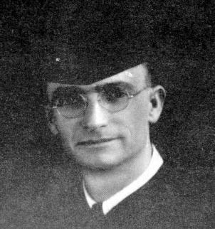

Dr. Alfred Aaron Brian II

He attended Wayland Baptist College, Howard Payne College and Hardin-Simmons University. He served as pastor of First Baptist churches in Merkel, Levelland and Brownfield, Texas; he also was District Nine Missionary. He was Vice-President of Howard Payne College from March 1, 1950, to July 31, 1953. He went to San Antonio as Superintendent of Missions. April 1, 1954. He believed strongly in Christian Education.

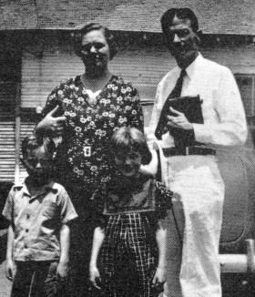

Elton Lee Brian, Bobbie Helen Brian Dyer,
Ora Lee Dopson Brian and Alfred Aaron Brian II.

This picture was made August, 1940, Redwine Baptist Church, Tahoka, Texas. A. A. was helping William Preston Brian in a revival.

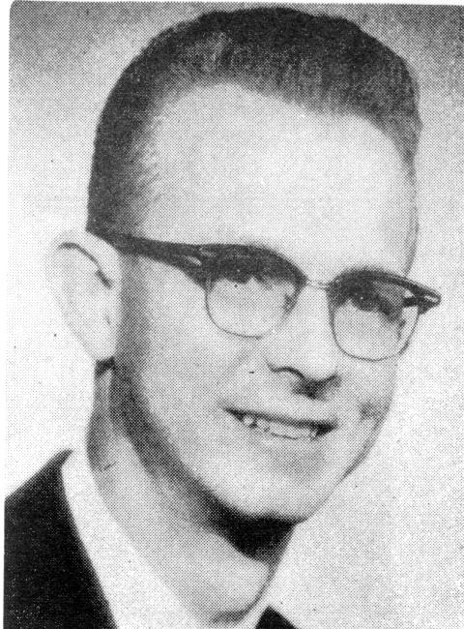

Alfred Aaron Brian Jr.

Minister of Education

BORN
DECEMBER 18, 1931
BROWNWOOD, TEXAS

DECEASED
MARCH 8, 1959
FORT WORTH, TEXAS

Alfred Aaron Brian III

DR. A. A. BRIAN, above, superintendent of missions for San Antonio, died during the evening of November 22. Reports are that he arrived home feeling well and died suddenly.

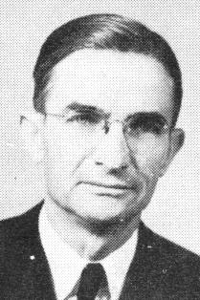

Dr. A. A. Brian, above, superintendent of missions for San Antonio died during the evening of November 22. Reports are that he arrived home feeling well and died suddenly.

Dr. A. A. Brian City Missionary, San Antonio, Texas, 1954 until his death in 1955. This picture was made just a while before his death.

23. MELTON DESSEX AND MAMMIE CRAIG BRIAN

Melton Dessex Brian, b. December 7, 1902, in Eastland County, Texas, the sixth child of Kleber Dessex and Elizabeth Melton Brian. I always felt that he portrays our daddy more than any of the boys. He was always more serious and looked on life in a different way than the others. He is the only deacon, other than our daddy, as the other five boys made preachers. A man at Plains, Texas, asked Dessex why he didn't make a preacher and then it would have been one hundred percent. Dessex's answer was, "Well, I thought one in the family ought to make an honest living." He has always been a real good Christian and his word as good as gold. When he told you something it was always that way.

Melton Dessex Brian was m. to Mammie Craig, August 22, 1922, at Plains, Texas. Mammie was the daughter of Mr. and Mrs. R. J. Craig of Tatum, New Mexico. To this union three sons were born as follows

1. J. D. Brian, b. June 2, 1923, at Estacado, Texas, m. Margaret Pundt of Canadian, Texas, December 1, 1944. Bro. Hicks performed the ceremony in the First Baptist Church, Arnett, Oklahoma. They have two children:

a. Lynn Brian, b. July 18, 1946, in Kermit, Texas. He has surrendered for the ministry.
b. Neita Kay Brian, b. March 18, 1956.

Margaret Pundt Brian d. suddenly in the Greenwood schoolroom at Richardson, Texas, September 23, 1970, and was buried at Canadian, Texas.

2. Melton Craig Brian (Bud), b. October 12, 1925, Estacado, Texas, m. Leta Mae Shaw in Sweetwater, Texas, December 19, 1946. To this union was born the following children:

a. Linda Sue Brian, b. March 25, 1949, m. Tom Nisbett and they live at 905 5th Street, Canyon, Texas.
b. Ronnie Craig Brian, b. October 7, 1950, Denver City, Texas.
c. Randy Mike Brian, b. July 12, 1953. Melton Craig Brian's address: Box 1462, Denver City, Texas 79328.

3. Rufus Lee Brian, b. November 28, 1931, Tatum, New Mexico, m. Margaret Nell McDonnell, Plains, Texas. To this marriage the following children:

a. Jerry Ray Brian.
b. Rita Joyce Brian.
c. Debbie Joe Brian.

Rufus Lee Brian's address: Route I Plains, Texas 79355.

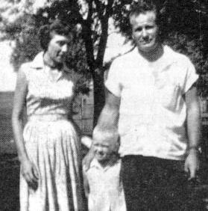

Leta Mae Shaw Brian, Ronnie Craig Brian, and Melton Craig Brian.

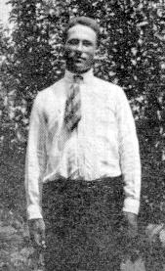

Melton Dessex Brian

This picture made at the Kleber Dessex Brian home place at Estacado, Texas, in the month of September, 1919.

THE RUFUS BRIAN FAMILY

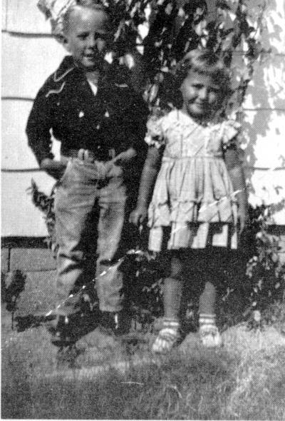

Jerry Brian and Rita Brian

24. ROSA VICTORIA BRIAN HOWARD

Rosa Victoria Brian Howard, b. March 2 5, 1905, Eastland County, Texas, the seventh child of Kleber Dessex and Elizabeth Melton Brian. A slight, reflective woman who looks deceptively fragile but, like her mother, ninety-five pounds of pink porcelain, so put together by muscles and vigor which never seem to tire. As I recall, always a neat person, knowing how to dress to make her clothes bring out the best quality in good looks.

She was married to Anderson Arcemus Howard, December 20, 1923. The ceremony was performed by Rev. Hill of Idalou, Texas. Arcemus was born July 27, 1895, in Overton County, Tennessee, the son of Alexander Portman Howard and Eliza Matilda Craft Howard. In 1897, the family moved by rail to Montague County, Texas, although two of the older sons made the trip through by teams and wagons.

Rose and Arcemus have four children, one girl and three boys as follows:

1. Betty Rose Howard Cannon, b. March 30, 1926, at Estacado, Texas, m. James Robert (Bill) Cannon, September 29, 1946. They have one daughter:

a. Sharon Ann Cannon, b. March 9, 1948. Their address, 600 W. 11th Street, Plainview, Texas 79072.

2. Ray Arcemus Howard, b. June 30, 1929, m. Dell Teague Howard, October 28, 1950. They have one daughter:

a. Rhonda Kay Howard, b. August 15, 1954. Their address: Wright City. Oklahoma 74766.

3. Jimmy Craft Howard, b. February 18, 1923, m. Doris Gunkey Howard, December 28, 1951. They have one son, Garry Don Howard, b. October 31, 1963. Jimmy is making the army his career. He is now in Vietnam and his wife and son live in Amarillo, Texas. See the chapter on military life for other things about Jimmy.

4. Bobby Joe Howard b. December 23,1934, m. Gladys Satterfield Howard, May 8, 1957. They have one son:

a. Cecil Ray Howard, b. February 6, 1958. Joe lives in Amarillo, Texas.

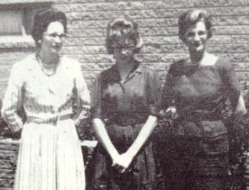

Left to right: Betty Howard Cannon, Sharon Ann Cannon and Rosa Brian Howard.

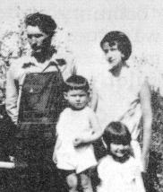

Betty Howard Cannon, seated; Ray Arcemus Howard, standing in chair;
Arcemus Howard and Rosa Victoria Brian Howard.

25. WALTER LEE AND EUPHIA SMITH BRIAN

He wasn't tall and he wasn't short, but his shoulders were broad and his legs and arms always seemed to me overly muscular. In the community in which we lived much depended on the fighting ability of those attending the local school. This alone made it necessary for me to defend my honor, to fight or to play the part of a coward. This is where my brother came in and was compelled to prove his worth; he was pushed into a fight with the largest boy in our school and had to crush the bully with his fist into the playground dust. From this time on I wasn't afraid as I could now say, "Yonder's my big brother." He wasn't a bully, but he wouldn't let others run over him or anyone else.

Walter Lee Brian, b. January 15, 1907, Desdemona, Texas, the eighth child of Kleber Dessex and Elizabeth Melton Brian. He was married to Euphia Smith, September 12, 1926, ceremony performed by C. N. Carr, pastor of Estacado Baptist Church. They have three daughters:

1. Maggie Lee Brian Graham, b. November 15, 1927. She has three children:

a. Debra Ann McMinn, b. March 31, 1953, Hale Center, Texas.
b. Dudley Brian McMinn, b. January 29, 1960, Wichita Falls, Texas.'
c. Candace Jill Graham, b. October 30, 1968, Lubbock, Texas.

Maggie's address: 2308 - 61st Street, Lubbock, Texas

2. Euphia Jean Brian Durbin, b. May 1, 1929, Tatum, New Mexico. They have
two sons:

a. Micheal Wayne Osthus, b. March 13, 1950, Amherst, Texas.
b. Patrick Lee Osthus, b. January 17, 1954, Amherst, Texas.

Their address: Boise City, Oklahoma.

3. Arlene Cheryl Brian Boggs, b. December 6, 1932, Tatum, New Mexico. She has one son:

a. Gregory Lee Boggs, b. March 17, 1951, Plainview, Texas.

Their address: Lubbock, Texas.

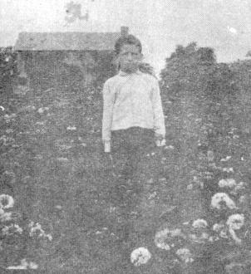

Walter Lee Brian, made when eleven years old.
The old home place near Desdemona, Texas.

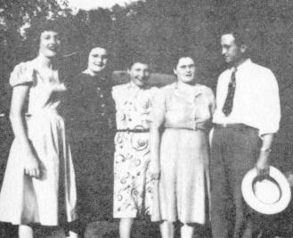

From left to right: Jean Brian Durbin, Maggie Lee Brian Graham,
Arlene Brian Boggs, Euphia Smith Brian, and Walter Lee Brian.
26. WILLIAM PRESTON (TED) AND INEZ CHERRY BRIAN

I tried to get my wife to write this article about me, but she refused, saying she knew a lot of things that might not be told. Have you ever tried to write something about yourself? If you have, you know the delirium that I am in. Just about what the Bible says in James 1:23-24: "...like a man who looks in a mirror and sees himself as he is. He takes a look and then goes away; and then forgets what he looks like."

William Preston (Ted) Brian, born October 9, 1910, Eastland County, Texas, the ninth child of Kleber Dessex and Elizabeth Melton Brian, m. Inez Cherry, Lorenzo, Texas, December 25, 1933. Inez the daughter of John Melvin and Annie Atwood Cherry. The Lord blessed our home with four children, two boys and two girls as follows:

1. William Preston Brian, Jr. , b. October 15, 1934, m. Ruth Rowlands, March 11, 1956, in Honolulu, Hawaii. Ceremony performed by Rev. J. W. Ware, pastor of a Southern Baptist Church where they attended and met. They have two sons:

a. Ronny Duane Brian, b. June 24, 1957, Edwards, California, in Air Force Base Hospital.
b. Joel Kevin Brian, b. November 24, 1960, in Hollywood, California.

Preston and Ruth do hospital work, called to help suffering humanity. Their address : 3750 Tomlinson, Riverside, California 92503.

2. Annie Beth Brian Roby, b. November 11, 1935, at Lorenzo, Texas, m. Alexander Eugene Roby, December 23, 1955. Ceremony performed by Ted Brian, Emmanuel Baptist Church, Dos Palos, California. Lex's parents are Albert Eugene and Beatrice Brown Roby, Alenreed, Texas. Grandparents: Thomas Jefferson and Harriet Graham Roby, State of Nebraska. Beth and Lex have three children:

a. Rodney Eugene Roby, b. March 19, 1957, born in Oroville, California.
b. Delinda Renee Roby, b. March 4, 1958, in Hollywood, California.
c. Rebecca Ann Roby, b. July 13, 1963, Lubbock, Texas.

Beth and Lex are teaching school in 0dessa, Texas. Address: 2800 Teakwood, Odessa, Texas 79760.

3. Thomas Jefferson Brian, b. July 4, 1944, Abilene, Texas, m. Edith Ann Emmett of Dallas, Texas, August 22, 1969, in the First Baptist Church of Lorenzo, Texas. Ceremony performed by Ted Brian. Edith Ann's parents, Dr. and Mrs. George E. Emmett. Tom and Ann are in the teaching profession. Ann is teaching in the elementary school and Tom is the elementary principal. Their addressBox 141, Lorenzo, Texas 79343.

4. Cherrydel Brian, b. January 8, 1946, Tulia, Texas. She is art instructor in the Nimitz junior High School, Odessa, Texas 79760.

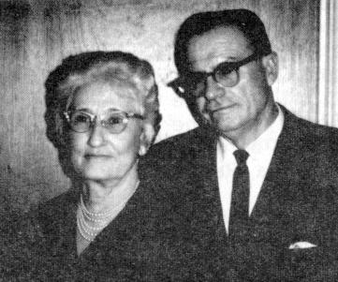

Inez Cherry Brian and William Preston (Ted) Brian

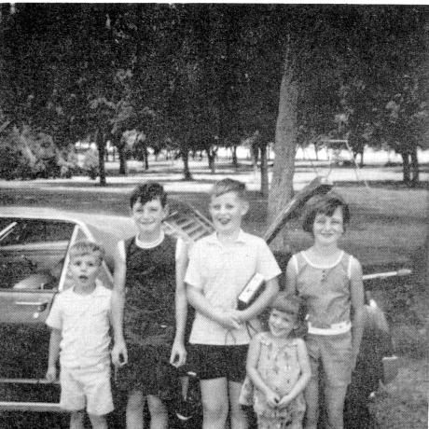

Left to right: Joel Brian, Rodney Roby, Ronny Brian, Rebecca Roby, and Renee Roby.
Picture made in Lubbock Park, Lubbock, Texas.

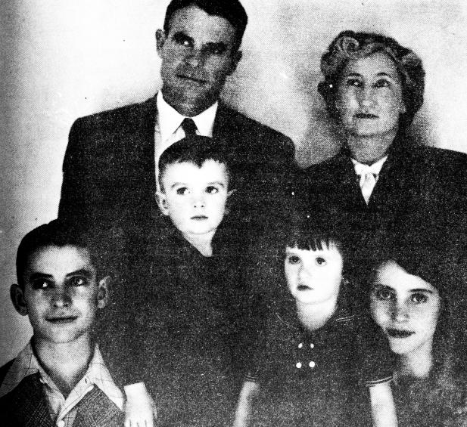

Left to right: William Preston Brian, Jr., Cherrydel Brian, Beth Brian Roby,
Thomas Jefferson Brian, William Preston Brian Sr. and Inez Cherry Brian.

27. DALTON DELMONT AND JOY SMITH BRIAN

Someone said, "His world is horses." One of the best of riders with his long slim body and legs, some six feet four inches tall, a know-how horse trainer. He loves horses, but in return he has the know-how to teach horses to return his love in their very actions. He loves men also. One day while working for the Texas Highway Department at Silverton, Texas, God spoke to him and called him to lasso men for Him. From that day forward he has been a beloved pastor at the following churches: Fairview near Levelland, Texas; Rockyford, Texas; Gomez, Texas; then the Lord spoke to him to follow His call to California and he is known and loved throughout the Golden State. He has to turn many revivals down because of the number. He was the pastor at the following places in California: First Southern Baptist, Turlock; First Southern, Fillmore; First Southern, Coachello; First Baptist, Firebaugh; First Southern, Norco; and, at present, pastor, First Southern, Yucaipa. Their address: 12463 - 15th Street, Yucaipa, California.

Dalton Delmont (Dock) Brian was b. May 3, 1913, Eastland County, Texas, the tenth child of Kleber Dessex and Elizabeth Melton Brian, married Joy Smith on April 11, 1937. She was the daughter of Mr. and Mrs. Roy M. Smith of Estacado, Texas. The ceremony was performed by W. P. Brian, First Baptist Church, Ropesville, Texas.

They have one daughter and two sons:

1. Gayle Brian, m. Larry Thomas. They both surrendered as missionaries and are doing mission work in Hawaii. They have two children:

a. Roger
b. Pamela

Their address: 2009 Oahu Avenue, Honolulu, Hawaii 96822.

2. Dalton Brian, b. in Lorenzo, Texas, m. a girl in Coachello, California. Dalton Delmont Brian performed the ceremony. They have five children and their address: Box 125, La Quinta, California 92253.

3. Billy Don Brian, m. Linda Morris May 25, 1963, First Baptist Church. Rev. D. D. Brian performed the ceremony. They have two children: Rebecca Sue, b. August 11, 1969; and they have another child born in 1971. I am sorry I have no more information.

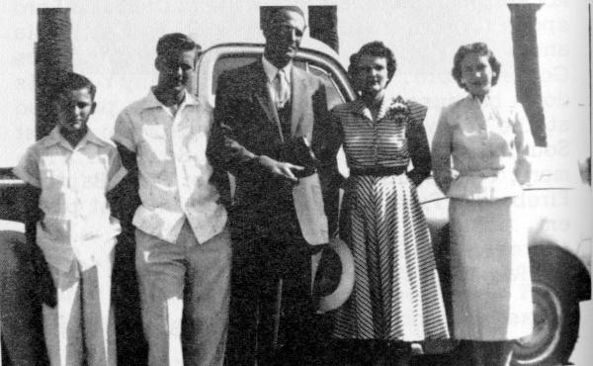

From left to right: Billy Don Brian, Dalton Brian, Dalton Delmont Brian,
Joy Smith Brian, and Gayle Brian Thomas.
28. SAMUEL ELLIS AND BILLIE SWAIN BRIAN

He must have inherited the zeal and determination of his father and the tenderness of his mother. His hearty handshake, his quick smile, his sensitive alertness to your needs, his ability to call you by your name carries with it the impact that he is your friend, which he is indeed. He had some hard going in life, many would have given up, but the work of God called him on and he would not look back but kept "pressing toward the prize in Christ Jesus." A world traveler, but never forgetting that he is a heavenly traveler and needs to be rich toward God.

Samuel Ellis Brian, b. October 3, 1915, Eastland County, Texas, the eleventh child of Kleber Dessex and Elizabeth Melton Brian. Married to Billie Swain on November 2 9, 1944, in Brownfield, Texas. Ceremony performed by Dr. A. A. Brian, pastor of First Baptist Church. Billie is the daughter of William Graham Swain, b. in Meridian, Mississippi. Her mother, Rowena Ruthford Swain, b. Clay County, Kansas.

Sam and Billie have two children:

1. Larry Swain Brian, b. November 4, 1946. Larry is a Captain in the U. S. Air Force.

2. Judy Rowena Brian, b. November 1, 1951. Judy is attending Texas Tech, Lubbock, Texas.

Their address: Chaplain Lt. Col. and Mrs. Sam Brian, 9087 Lawhon, Laughlin A.F.B., Del Rio, Texas 78840.

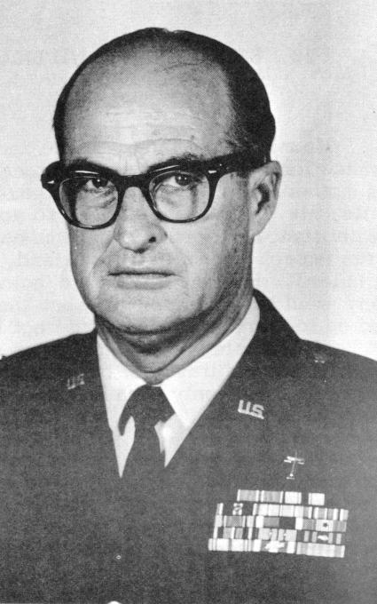

Chaplain Lt. Col. Samuel Ellis Brian

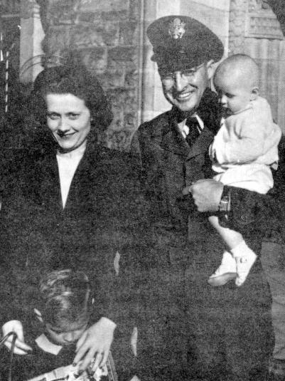

Left to right: Larry Brian, Billie Swain Brian, Judy Brian, and Samuel Ellis Brian.
This picture made in France.
29. CAVORTING

Cora Bell Brian Greenhaw still laughs about the night that Ford and Sam, her son and brother, took a bath at her home and put Sloan's White Liniment on a good case of itch. It set them on fire and they couldn't keep from running. Cora's home was out in the country. It was a very cold night and the two young men took off running around the house in their birthday suits. Yes, it killed the itch, and almost took the hide off of each young man.

Norma Jeff Brian Brisco won't forget the many pranks of her younger brothers. One day before her marriage she and Frankie started to go to a Sunday afternoon singing convention at Howard schoolhouse. The brothers had already visited the buggy and had exchanged the front and back wheels. They rode on their necks almost to the schoolhouse before deciding to make the change.

When I was eight years old, I was down at the Salt Fork of the Brazos River where some men were working on the washed-out bridge. As I was listening to them talk, one of the men said, "Well, I am going to see my Lou this Saturday night." I only knew one Lou and that was my sister, Loucille Brian Evitt, that's who we called Lou, so I said, "Lou who? Lou at our house? " The other man really got a laugh at his and my expense. My brother Walter always had big ears and he couldn't wait until he got to the house and told everyone.

Well, Lou really worked me over with her tongue.

Alfred Aaron Brian was pastor of the First Baptist Church of Merkel, Texas. He was asked to come to Sweetwater to bring the main message to a Negro Baptist Association. The Negro moderator introduced Alfred in such a wonderful manner that he could never forget it. It was as follows. "This Reverend Doctor Brian is such an outstanding preacher. He is a man with very high forcenarity (undefined). In the Brian family there are five preachers and one deacon, all brothers, and they are the most constipated (consecrated) bunch of men that I have ever seen." No one laughed but Alfred never got tired of laughing about it after leaving there.

Melton Dessex Brian was helping stack feed for a neighbor family. That day at noon he was really embarrassed when a grown young woman of the home spoke up and said, "Dud, will you please pass the thirty-thirties," meaning the red beans. It took a long time for Dud to live this down.

One day Alfred, Walter and I were in a grocery store in Lubbock, Texas. Walter was over at the fruit counter looking at some grapefruit. He picked up a real large one and said, "Look here, this is the largest lemon I have ever seen." It was a few minutes before he could be persuaded that it wasn't a lemon but a grapefruit. Well, it was just another one of those times when a country boy had come to town.

Dalton Delmont Brian, better known as Dock, always kept things moving rather lively when he was around. One day the Watkins man came by in his hack, pulled by two spirited horses. Dock ran out and stopped him, asking him in this manner, "Hey! Do you have any wax?" The man answered, "Yes." Dock's reply, "Then give me some." The man gave him a package and then asked Dock for the nickel, and Dock said, "I don't have one." The man gave him the chewing gum very begrudgingly but Dock was satisfied with his mouth full of gum.

Samuel Ellis Brian, known as Cobb to his boyhood friends, was in his first year of school at Estacado, Texas. The teacher came around one morning to see who had dirty hands among the girls and boys. She discovered Sam had rusty hands. He began to cry and say, "We have nothing at home to wash our hands with but old lye soap." This was the truth. My mother made lye soap all the time to wash the clothes and dishes and for us to bathe and wash our hands with. One of my older brothers was going with this young schoolteacher but this ended the romance between them as he couldn't face her after the lye soap farce. Cora Brian Greenhaw was a bit embarrassed about the incident and went to the store and purchased some soap for our family. I can look back now and see that the hard days we had were the making of us. If I hadn't had the hard times at home to season me I could have never withstood the hard times I encountered in college. Many is the time I had to face things without money.
30. ANDREW EVANGELISM

"At once Andrew found his brother Simon and told him, 'We have found the Messiah.' Then he brought him to Jesus." John 1:41-42.

Alfred Aaron Brian told me the following story about soul winning and the man he won to the Lord.

Levi Clements lived in Levelland, Texas. He had a large family and was not a Christian. The Lord laid this man on Alfred Is heart. Alfred would go to see him and Levi would go out the back door and not return until after Alfred left. One day Alfred found out that he was out in a corn patch gathering roasting ears to can. Alfred caught him out in the cornfield. It was real hot. Alfred got Levi down on his knees and there they stayed talking to the Lord, taking a sweat bath for some time. Levi gave his heart to the Lord there. He came on and joined the First Baptist Church. His family also were saved and joined. A short time later, the Lord called Levi Clements to preach the Gospel. He was the pastor of churches in different parts of the high plains and some down under the caprock, before the Lord called him home. Alfred would say, "Levi was sure hard to win, but, Ted, there is nothing too hard for the Lord.

Walter Lee Brian -- 'It is difficult for me to say which is the most outstanding conversion during my ministry, as I have seen hundreds saved. The one that comes to my mind is Long John Burson, commonly called Long John of Silverton, Texas. Mr. Burson came to Silverton in the early days to ranch and to have the best ranch in West Texas, and that he did, with twenty-two sections of level land and the best cattle that I had ever seen. I was warned to stay away from Mr. Burson, as he wouldn't give me a very warm reception. As I had worked for several ranchers in New Mexico, I felt like that I could speak his language. I drove out one morning nine miles east of Silverton, mind you, I didn't leave until after 11 o'clock, the reason to eat a meal with him. No rancher ever turns a man away at mealtime. This is the law of the ranchers. We had the finest meal together. Our conversation during the meal was cattle. When I got ready to go I asked him about coming to church, and he gave me his promise to come and he did. One Sunday morning, Long John walked the aisle and accepted Christ. Crying, he turned to me and said, "I have a boy and a wife in this service, and they are lost. I want you to go and bring them to the Lord." I said, "Mr. Burson, the boy is your boy, you go and bring him to Jesus. " He went back to where they were standing and in just a few minutes both of them came forward, taking Christ as Lord. I will never forget three outstanding statements he made to me that night I baptized him.

1. "Preacher, I would give all my property that I have if someone had won me to the Lord when a junior boy.

2. "I am 79 years and 6 months old and don't have many more years to live, but I am going to do my best while I do live."

3. "Preacher, who gives the most in this church? " (I had to tell him I didn't know.) "Well, here is a check for $1,500.00 for the church." He didn't live too many months after this, but he was always at church, rain or sunshine. His favorite song was "Heavenly Sunshine" and he would always ask the song director to sing it. God called him home just a few days past his eightieth birthday, and the choir sang for the family and for Long John, one more time, "Heavenly Sunshine! "

William Preston (Ted) Brian -- I suppose I will have to say like Walter Lee Brian, I have seen so many people saved that it is hard for me to tell you the most outstanding. Will you read this about Joe Woodard? Joe was a junior boy about eleven years old. His father was the superintendent of the rice mill, some two miles south of Dos Palos, California. One of Joe's teachers, John Ray, a Christian, asked Joe where he went to church. Joe didn't know anything about church, as his folks had never taken the family. He gave him a Gideon New Testament, and made a date to come and get him and take him to Sunday school and the Church service. In some two or three months Joe accepted the Lord. On that Sunday afternoon, Mrs. Brian and I went out to the Woodard home to meet them and talk to them about Joe's profession of faith, and see if he could be baptized. Mr. Woodard was out at the mill shooting rats with a twenty-two rifle. When I told him who I was, he got angry and told me his boy couldn't be baptized, and for me to get myself off his property. In leaving, I shouted to him, "Don't stand in the way of your boy. He had several girls but only this one son. As I drove back to Dos Palos, I was talking to the Lord and saying, - "Please, Lord, Please don't let that man stand in the way of that boy."

About seven o'clock on Monday morning my doorbell rang and as I opened the door, there stood Mr. Woodard. I asked him to come in and be seated. He wouldn't sit down but continued to stand and twist his hat around with both hands all the time that he was there. He began the conversation by saying, "Preacher, I want my son baptized." I asked him why. This was his answer. "I suppose I saw a vision from the Lord last night and it scared me. I saw my boy playing baseball with some other boys and he chased the ball across the street. A car hit him and ran over him. I ran out in the street and grabbed him up in my arms and his blood ran all over my clothes and he died in my clasp. I awakened and was wet with cold sweat and trembling all over. I don't want to stand in the way of my boy."

I asked him if he would come and see his son baptized the next Lord's day. He promised and was there. I baptized the boy and he viewed this beautiful Bible ordinance; then he heard me preach and when the invitation was given, his intermediate girl, about 14, was saved. That gave me another opportunity of going into the home and talking to the mother about Dorothy being baptized. Mrs. Brian and I went and Mrs. Woodard trusted the Lord and wanted to be baptized that night with her daughter. I talked to Mr. Woodard and he promised me he would be in the services that night. He came and watched his wife and daughter buried with Christ in beautiful baptism. He really listened as I preached God's message that night and when the invitation was given he came and gave his heart to the Lord.

He waited some six months and would not be baptized into the church. He came to every service and even gave his tithe, but he would only shake his head when I would talk to him about being baptized. One Sunday morning he came and said that he was ready. After I baptized him on Sunday night I asked him why he had waited six months. "I suppose that you have heard people call me King Woodard, haven't you? You don't know why they call me that. I am the King of sinners. I would beat my wife when I would get drunk and slap my kids down. I could drink more liquor than any man living and stand up under it. I would drink with men, get them drunk,
and win all their money. Even this house in which I live, the money to buy it was won in a crap game. Preacher, since I have been saved, I have been reading my Bible, and found where Paul said that he was the "chief of sinners." I also was the chief of sinners. Now, why did I wait? I just wanted to be sure that God could save me and keep me saved. In the six months that I have waited I have found Him able to keep me, so when I proved this to myself I was ready. I just didn't want to start something and not go all the way. You know, Preacher, God is bigger than what I thought."

I was his pastor for some two or three years after this and saw him grow as a Christian and, bring several families who worked at the mill to the church and they would find the Lord. The last time I was in Dos Palos for a revival, I was asking about him and found out that he had moved back to Arkansas, his home state. Well, what about his walk with the Lord, I asked. The answer made me happy. "He is the Sunday school Superintendent in the little rural church where they live."

Dalton Delmont Brian says: The one, out of the many soul-winning experiences, happened while I was pastor of Fairview Baptist Church, Levelland, Texas. I had won Edison and Margaret May to the Lord and baptized them. Several months later our church was in a revival with my brother, William Preston Brian, pastor of First Baptist Church, Plains, Texas, as the evangelist. After a night service, as Edison and Margaret were having their devotional Bible reading and prayer, Margaret got under conviction for Edison's parents, Mr. and Mrs. May. Edison refused to go with her and she called my home, asking us to come over to the May, Sr.'s home. Margaret went on over to the home and got them out of bed and told them why she was there.

When my wife Joy and my brother arrived, they were seated in their chairs dressed in their night clothes. We received a poor and cold reception. My brother talked to Mr. May and I would talk to Mrs. May while the others prayed. This went on for some time, then I saw tears running down the face of Mr. May. This was the first indication of any response and I knew that the Holy Spirit was working. All at once Mr. May said out loud, "I can't be saved! I was saved when I was nineteen years of age." He re-dedicated his life to the Lord and Mrs. May accepted the Lord as her savior. Next morning in the morning service they both came for baptism. This was a great surprise for the whole church.

Men and women who read this, remember, Jesus said, "But who shall offend one of these little ones which believe in Me, it were better for him that a millstone were hanged about his neck, and that he were drowned in the depth of the sea." Matthew 18:6.

Dear Reader, this statement was so important that it is recorded in Mark 9:42 and Luke 17:2.
31. YAP

It "Yap" means to talk or to gab and that is what you will read here.

I was in a revival with a preacher friend, south and east of Abilene, Texas. We were eating the evening meal on Sunday evening. It was almost dark but not enough to light the lamps. It was the time just before screened doors and windows. The flies were real bad. The pastor and I were seated on one end of the table and the man who was leading the singing for the revival on the far end. It was dark enough that he could see a raisin pie, so he thought, on our end of the table. He called the pastor by name, asking him to pass the raisin pie. He continued to tell how he just loved that kind of pie and that his mother was the best raisin pie baker in the whole country. The pastor picked up the pie, which was an egg custard pie, and all the raisins flew away.

While I was pastor at Sundown, Texas, my family and I were having dinner with the Peck family. Several other people were there for dinner also. While eating and talking and having a big time, I suppose I was telling some tall tale, when my son, William Preston Brian, Jr., looked up at me and said, "Daddy, are you preaching or telling the truth?" It took a lot of living for me to live this down. Even now, when I see one of the Peck family they will ask me, "Brother Brian, are you preaching or telling the truth?

One of the deacons in the First Baptist Church, Plains, Texas, was talking to my oldest son and made this comment. "Preston, your daddy has been pastor here for nearly four years and I have never heard him preach the same sermon the second time. Where does he get so many sermons?" Preston replied, "That's what you think, he preaches the same sermons over and over, but he just hollers in a different place."

I was helping Curtis Jackson in a revival out southwest of Brownfield, Texas, in a rural church, now disbanded, and we were visiting in the sand-hills. We came to a lone house in the deep sand and went up to the door and the lady of the house asked us in, Brother Jackson talked to her, asking her about her church affiliation and talking to her about the Lord. He found out she wasn't a Christian and he read her the plan of salvation from God's word, Then he asked her about having prayer. She wanted to have prayer and he called on me to lead the prayer. I had just started to pray when she interrupted me by saying, "Wait a minute, please." She went to the door and began to call her some seven or eight children in a very shrill voice, "Hey, kids, come on in here and see this preacher pray." The kids came, but about all the praying had been knocked out of me. Whenever Brother Jackson sees me, he always reminds me of this by saying, "Hey, kids, come on in here and watch this preacher pray."

I was performing my first marriage ceremony, the first Sunday as pastor of Dos Palos, and like all other pastors, I wanted to make a good impression on the people of the church who were present for the wedding. About the middle of the ceremony I heard a cat mewing at the top of his voice. Someone had left the back door to the church open and he had found his way in. He was a big black tomcat. He had his tail sticking straight up and walking stiff legged and every two or three steps he was letting out his loud love call. He walked between me and the couple getting married. I tried my best to go on with the ceremony without a bother. To my left in the church auditorium sat a bunch of young women, some eight or ten, with my own daughter, Beth Brian Roby. They all got to laughing and almost broke up the service. After the service the young man and woman who were married asked me the old question, "Brother Brian, will that black cat bring us bad luck?" They were very serious about this. I assured them that it should be good luck for them, because when they got into a fuss to always remember the incident about the black cat. I saw them some time after the wedding, as they had moved to Oregon, and they laughed and said, "Brother Brian, it works. When one of us gets mad or something and begins to spout off, one or the other of us calls to mind the black cat incident and would you believe it, it always works."

My brother, Dalton Delmont Brian, was pastor of a church west of Plainview, Texas. I would call the name of the church, but I had better not, and you will know why after you read this. Well, the church liked the Stamps and Baxter songs and wanted to use them in the church service. Dock thought them all right in their place but not good for the worship service. One of the members bought several of the books named and they would use them every service. Dock wondered what to do and how to stop this. As all the men in the community were too lazy to build the fire, mind you, it was made with coal, Dock had to do it. He needed some paper to catch the kindling on fire. It ended up with him taking a song book or two to start the fire. In a few weeks the people began to complain about their songbooks disappearing. Needless to say, within a few weeks, the old songs of Zion were being sung again. The church and everyone very happy and the Lord blessed them with a great ingathering of souls.
32. WOW

Joseph Thomas Brian, son of Thomas and Narcissus Brian, enrolled June 3, 1861, was mustered into Confederate service at Orangeburg, June 4, 1861. He was made Lieut. Comdr. C (K) 5th, South Carolina Volunteers on August 31, 1863. On December 31, 1864, he was made Captain. He was wounded and captured and made a prisoner at the battle of Gettysburg. Freed after the war. Disappeared in the Galveston flood in 1900.

Dr. Alfred Aaron Brian attended Wayland Baptist College, Hardin-Simmons University and Howard 'Payne College. He was the pastor of the First Baptist Church in Littlefield, Levelland, and Merkel, also District Nine Missionary. He was Vice-President of Howard Payne College from March 1, 1950, to July 31, 1953. He went to San Antonio as Superintendent of City Missions, April 1, 1954, where he served until called home, November 22, 1955. 1 have heard so many say, "He was like Enoch, he walked with God. "

Chaplain, Lieutenant Colonel, Samuel Ellis Brian received his BA degree from HardinSimmons University, Abilene, Texas, and the Bachelor of Divinity and Master of Religious Education from the Golden Gate Seminary, Mill Valley, California. He entered military service in 1942, and is a veteran of World War II, Korea and Vietnam. He served in India, Burma, France, Germany, England, Alaska, Japan, Taiwan, Iwo Jima, Thailand and Vietnam. He recently completed a tour of duty in Southeast Asia and was awarded the Bronze Star for duty with the Air Force, and the Vietnam Medal of Honor, First Class, by the South Vietnamese Government for humanitarian work done with the local people.

Greetings from Joe, Leona, Carl, Jonathan and Charlotte Tarry. A Christmas card greeting from Joe Tarry and family, grandson of Fannie Brian Tarry, of Lovington, New Mexico. Joe and Leona, his wife, are our missionaries to Brazil. Their address. CAIXA Postal 285, Governador Valadares, Minas, Brazil. Joe has been home since this Christmas card. He attended our last Brian reunion, 1971, at Lubbock, Texas.

A whale of a job. You have to say this about the work of Walter Lee Brian, pastor of Calvary Baptist Church. Notice the accomplishments. He is beginning his seventeenth year as pastor of Calvary Baptist Church, Alamogordo, New Mexico. Served on State Mission Board fifteen years. Vice-President of New Mexico Convention one year. Moderator of Mountain View Baptist Association for eleven years. Also served his church as pastor and served his association as Missionary for one year. I still have to say, "whale of a job."

Dr. Kirby B. Tarry, grandson of the late Fannie Brian Tarry, is a Doctor of Medicine in Hawaii.

I mentioned in the first of the Brian His tory that we had preachers, teachers, singers, chaplains, missionaries, soldiers, farmers, ranchers, merchants, well, let us just say legion, as there are so many others.
How did the reunion start and why? After mother died in July, 1950, two of my sisters, Norma Brian Brisco and Rosa Brian Howard, talked to me and made the statement of the need for a get-together. After discussing it, we came up with the idea of a family reunion each year. We had our first reunion at the Plains City Park in 1951, with 73 in attendance. I was elected president and Rosa Brian Howard was elected secretary. Some pictures were made on this day which you ran see on the following pages. Samuel Ellis Brian flew in and was delayed, Alfred Aaron Brian, Sr., had to leave early. The two did not get to see each other.

1952, we met in the Mackenzie State Park, Lubbock , Texas; 61 were present for this reunion. Alfred Aaron Brian, Sr. was elected president and Lonetta Brisco Kitrell was elected as secretary. A good program was enjoyed by all.

1953 we met at the Mackenzie State Park with 53 in attendance. Officers were present and presided. William Preston Brian elected for president and Lonetta reelected as secretary.

1954, 49 present. The meeting called to order by the president at the Mackenzie State Park. A good program enjoyed. Alfred Aaron Brian, Jr. , elected president and for secretary, Norma Lou Brisco Childs was chosen.

1955, August 25, at Mackenzie State Park, with 72 present for this meeting. Everyone enjoyed the program presided over by Alfred, Jr. Dalton Delmont Brian was elected president and Rosa Brian Howard was elected secretary. Uncle Custer Brian present, 80 years old.

1956, August 30, with 83 in attendance. According to the records this is the largest number we have ever had. Dalton Delmont Brian and Rosa Brian Howard were re-elected to their office for another year.

1957, August 28, 50 in attendance. Walter Lee Brian was elected president and for secretary, Lonetta Brisco Kitrell was chosen.

1958, the count was 53. A good program and Walter and Lonetta were re-elected.

1959, August 11, we had 59 in attendance. A good dinner and program. (I don't know why this doesn't appear in all the minutes, as I have attended all the reunions and we have always had a good program plus plenty of good food.) In this year we had our first bank account with $20.07, not much but a start. Records show that Lonetta was both secretary and treasurer. Uncle Custer Brian attended this reunion at the age of 84. Telegrams were sent to Dock and Sam as they were unable to attend. Also we had catering service this year by Underwoods. Rosa Brian Howard was elected president and Lonetta was reinstated as secretary and treasurer.

1960, the reunion was in the Community Center, Lorenzo, Texas. Some fifty people were in attendance. A good program and lots of good food. Dalton Delmont Brian elected president and Rosa Brian Howard was elected secretary and treasurer.

1961, August 10, only 39 in attendance. This is the smallest number on record. The meeting was at Lorenzo Community Center. Dock and Rosa re-elected to serve another year.

1962, August 16, we had 70 in attendance as we went back to the Mackenzie Park. The highlight of this day was, "This Is Your Life Cora Bell Brian Greenhaw. " Dock was absent and Ted presided. William Preston Brian and Rosa Brian Howard were elected officers.

1963, August 1, 79 in attendance. A good program and a lot of food. Ted and Rosa re-elected.

1964, August 11, we went back to the Lorenzo Community Center where 62 attended. Ted and Rosa re-elected to office.

1965, August 10, we went back to Mackenzie State Park. (We have had all the other reunions here since.) Fifty-six people attended. Walter Lee Brian elected president and Lonetta Brisco Kitrell elected secretary and treasurer.

1966, no reunion. It was called off due to some deaths in the family just before the time.

1967, July 25, 72 in attendance. Mabel Mabry Greenhaw was elected secretary and treasurer and William Preston Brian elected president. Well, I suppose it finally came to dictatorship in our reunion -- we are still in office -or else we are so good no one wants to put us out.

1968, August 12, only 48 attended.

1969, the date absent, but we had 49 in attendance, one more than the year before. (I would like to make this statement. We have had many more to attend these reunions than what we count. We only go by the number who registered. Many come and eat and have to leave and don't write their name down. Some others come for only a little while and then have to go. The attendance is much better than the records show.)

1970, August 11, 41 in attendance.

1971, July 13, we had a very good crowd. Maybe not the best reunion, but one of the best. More were there that hadn't been in several years.

You will read this in the Brian History before the next Brian reunion on July 11, 1972, Mackenzie State Park, Lubbock, Texas. Let me say now, ya'11 come!

ACCOMPLISHMENTS

In 1954, we raised the money and had the cemetery lots curbed where Dad and Mother are buried in Lorenzo Cemetery. This was $110.00. Memorial flowers are placed on the graves most every year. In 1971, a head marker was placed on the grave of Moses B. Brian, in Antioch Cemetery, Lovington, New Mexico. I believe this was $120.00 and paid. Every year we pay our assessment to the Lorenzo Cemetery Association to help pay a caretaker's salary.

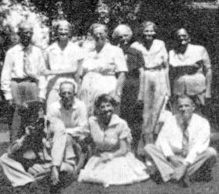

Left to right: Front row: Samuel Ellis Brian, Melton Dessex Brian,
Rosa Brian Howard and William Preston Brian.
Back row: Custer Brian, Cora Brian Greenhaw, Effie Brian Parr,
Fannie Lee Melton, Norma Brian Brisco, and Florence Tarry LeCroy.

Made in 1955, Lubbock, Texas.

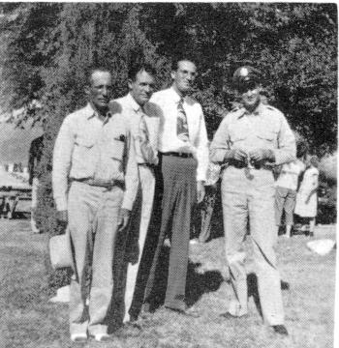

Left to right: Melton Dessex Brian, William Preston Brian, Dalton Delmont Brian,
and Samuel Ellis Brian. This was made in 1951, Plains State Park, Plains, Texas.

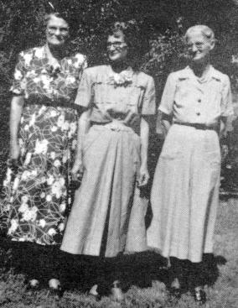

From left to right: Norma Brian Brisco, Rosa Brian Howard and Cora Brian Greenhaw.
Made at Plains, Texas, in 1951.
34. MEN OF VALOR

Billy Don Brian, Serial # RA 18842391, Company U. S. Army Signal Corps

1. December 2, 1966 to February 17, 1967, Fort Polk, Louisiana, Company D. 3rd. Bat. 2nd Training Brigade.

2. February 17 to May 12, 1967, Fort Mon, mouth, New Jersey, Company X.

3. June 5, 1967 to June 5, 1968, Hue-Pher Bai, South Vietnam, 131st Aviation Company.

4. July 6, 1,968 to December 1, 1969, White Sands Missile Range, New Mexico Headquarters and Headquarters Company. Date leaving service: December 1, 1969.

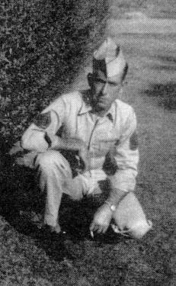

Charles Wesley Evitt, Jr. Taken in Rio Linda, California, September, 1955,
when he first came back from service in Japan.

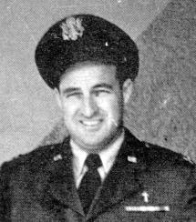

Chaplain, Lieutenant Colonel Samuel Ellis Brian

Chaplain Brian entered service in 1942, and is a veteran of World War II, Korea and 'Vietnam. He has served in India, Burma, France, Germany, England, Alaska, Japan, Taiwan, Iwo Jima, Thailand, and has been in Vietnam service twice.

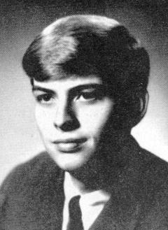

First Lieutenant Larry Swain Brian, completed officers training school at Lackland Air Force Base, San Antonio, Texas, June, 1969. He is serving as the Administrative Officer for the Field Maintenance Squadron. He is the son of Ch. Lt. Col. and Mrs. Samuel Ellis Brian.
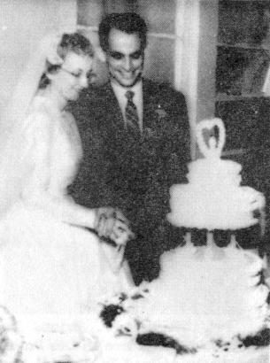

1st Lt. Ruth Rowlands Brian and Pvt. William Preston Brian, Jr. They were both working in Tripler Army Hospital, Honolulu, Hawaii, but they met in a Southern Baptist Church, where Rev. J. W. Ware was pastor. Rev. Ware performed the ceremony. Both were still in service when this picture was made on March 11, 1956.

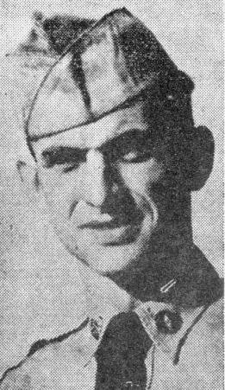
Pvt. William P. Brian, Jr., whose parents live in Dos Palos, recently arrived in Hawaii and is now stationed at Tripler Army Hospital, Honolulu. A graduate of Dos Palos Joint Union High School, he attended Howard Payne College, Brownwood, TX, before entering the army. (US Army Photo)

William Preston Brian, Jr.

(Photo not printable)

Jimmy Craft Howard
Made August 20, 1971, Dong Bathin, Vietnam

Inducted July 11, 1953, Ft. Sill, Oklahoma. Dog tag number 25873060. In Texas National Guard, 36 Infantry Division three years before enlisting in regular army. The places he was in army were: Ft. Sill, Oklahoma, four different times; Ft. Riley, Kansas; Ft. Polk, Louisiana; Ft. Hood, Texas; Ft. Leonard Wood, Missouri; Camp Kilmer, New Jersey; Ft. Hamilton, New York; and Ft. Smith, Arkansas.

He has seen overseas service in the following places: Germany, four times; France, Morocco; Lebanon; Turkey; and Vietnam, twice.

(Photo not printable)

Melton Craig Brian - Service Career - 4th Marine Division -Corpsman - PHM 3/C. Trained at San Diego and Camp Pendleton, California. Stationed at Pearl Harbor, and Tientsin, China.

(Melton Craig Brian would not write it and give me the history, but, I know that he saw some bad days of war during World War II. Three years or more of hard battles.)
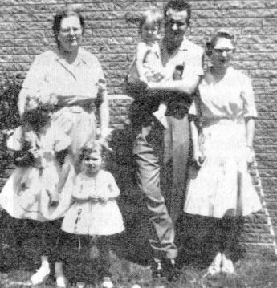

Left to right: Children - Kristi Kay Brian, Kellie Lee Brian,
Mrs. Ora Lee Dopson Brian, Elton Lee Brian, and Kay Calloway Brian.
35. XENIA

This poem is true and not just a fable,
It was written by me and my mother, Mabel.
It took several hours, we worked hard and long,
So I read a poem instead of a song.
Kleber and Elizabeth had a family of eleven,
Eight still here, three gone to heaven.
The father and mother have joined the three
While only eight remain of the family tree.
Well, first there was Cora, a precious thing is she,
If hadn't been her, there wouldn't be me.
Their children are two sons, and grandchildren four,
Now, listen real close, and I'll tell you some more.
And there's Norma, as happy as can be,
Who married Frankie, help trace their family tree;
Lonetta, Norma, Joyce and Nelda Frank,
Eight grandchildren, and one great one, I think.
In memory of loved ones so dear,
We know they are in heaven we have no fear.
Lou was a lovely person they say,
Left a husband with three children a while to stay.
Alfred, a preacher, his fame lives on,
A wife and three children he left-, bless his dear ones.
The ones left are Ora Lee, Bobbie Helen and Speck,
How much do we love them? A hug around the neck.
Now there's Dud and Mamie, bless their dear souls,
I know their hearts must be made of gold
They had three sons and lived in a dug-out,
But they didn't mind and really made out,
Rose and Arcemus had a daughter and three sons,
Raising a family during the depression wasn't fun.
They made it and were as happy as could be,
This is a lesson for you and for me.
The next is Walter, add "Koot" to his name,
Euphia has added a lot to his fame;
By giving him three lovely daughters that live near,
And then five grandchildren to them they hold dear.
Ted married a Cherry, but she's really a peach,
I don't know how many years he has preached.
God blessed them with Preston, Beth, that's not all,
As Tommy and Cherrydel came along in the, fall.
The next son was Dalton, he's called Dock,
I suppose he won Joy, with kind of a love shock.
She added three to the family tree, a daughter and two sons,
Namely, Gayle, Dalton and last came Billy Don.
Sam has traveled for God and for country,
A Chaplain and the rank Lt. Col. is he.
Billie, his wife, Larry a boy, and Judy a girl,
These are the three that make up his world.

Written by Mabry Greenhaw, great-grandson of Kleber Dessex Brian.

